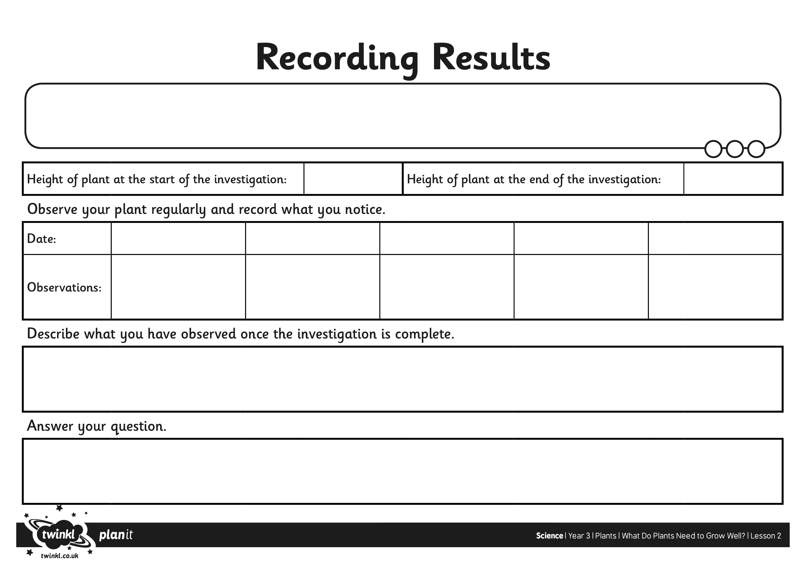
I can set up an investigation to find out what plants need to grow well.

