Y6 Tests

R1b. Can skim texts to get the general idea of the content of a piece

Skills Test 1

Commissioned by The PiXL Club Ltd.
August 2018
This resource is strictly for the use of member schools for as long as they remain members of The PiXL Club. It may not be copied, sold nor transferred to a third party or used by the school after membership ceases. Until such time it may be freely used within the member school.
All opinions and contributions are those of the authors. The contents of this resource are not connected with nor endorsed by any other company, organisation or institution.
PiXL Club Ltd endeavour to trace and contact copyright owners. If there are any inadvertent omissions or errors in the acknowledgements or usage, this is unintended and PiXL will remedy these on written notification.

© Copyright The PiXL Club Limited, 2018

R1b. Can skim texts to get the general idea of the content of a piece

Skills Test 1
Read the text and answer the questions below. Use the spaces provided to write your answers or put a tick or number in the correct box.
You have eight minutes to skim the text to find the answers. Ask someone to time you.
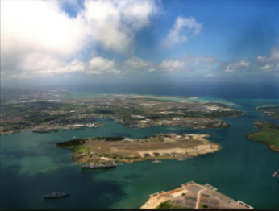
Hawaii
Hawaii is the 50th state to become part of the United States of America; it is also the most recent state to join (1959). It is the only state that is composed entirely of islands. It is located in the central Pacific Ocean off the West Coast of America. The word Hawaii means ‘place of the gods’ or ‘homeland’. Hawaii was originally called the Sandwich Isles, which is what Captain James C. Cook named the islands in 1778 in honour of the person who sponsored his travels, the Earl of Sandwich.
Hawaii is made up of 132 islands – eight main islands (Hawaii, Maui, Oahu, Kauai, Molokai, Lanai, Nihau and Kahoolawe) and 124 islets (small islands) and reefs (a ridge of jagged rock, coral or sand just above or below the surface of the sea). The Hawaiian islands are the tops of the world’s biggest mountain range. Under-sea volcanoes that erupted millions of years ago formed the islands of Hawaii.
Only two types of mammal are native to Hawaii – the hoary bat and the monk seal. The rest of the animals were brought there by people migrating to the islands.

- What is this piece of text about?

________________________________________________

- Is it fiction or non-fiction?

________________________________________________

- What is the main purpose of the text?

_________________________________________________________________

- What are the main ideas in the text?
Write four bullet points.

1b. Can skim texts to get the general idea of the content of a piece- ANSWERS

Qu | Answer
1 | A place called Hawaii
2 | Non-fiction
3 | To give information about Hawaii
4 | - Main ideas (accept any four of the following):  - When Hawaii joined America  - Where Hawaii is located/where it is  - Who discovered it  - What it is made up of  - What Hawaii is formed from  - Native mammals

