illegal
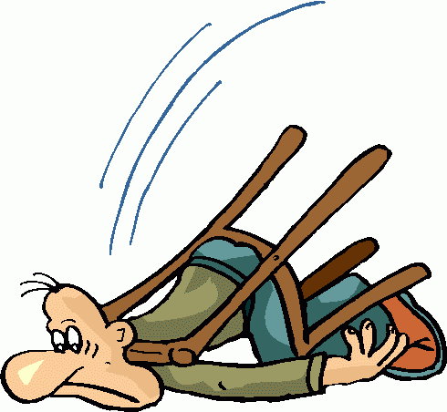
illegally
illogical
illegible
illiterate
illusion

irregular
irrational
irrelevant
irreplaceable
irritate
irritable

