unable
unafraid
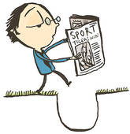
unaided
unaware
unbeaten
unblock
uncertain
unclean
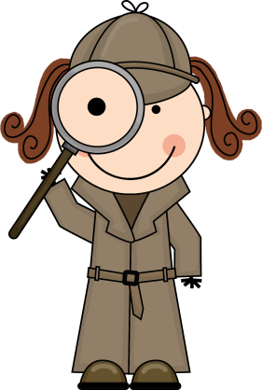
unclear
unclip
uncover
uncut
undo
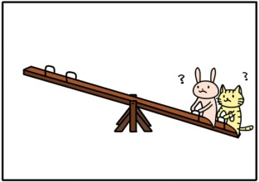
undress
unequal
uneven
unexpected
unfair
unfasten
unfit
unfold
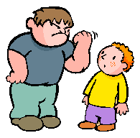
unhappy
unhelpful
unkind
unknown
unlike
unload
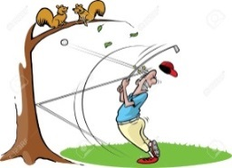
unlock
unlucky
unmade
unnoticed
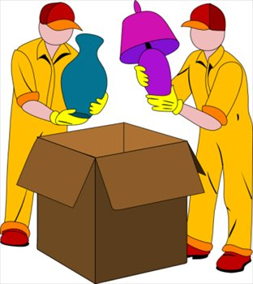
unopen
unpack
unpaid
unpick
unread
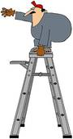
unreal
unsafe
unseen
unstuck
unsure
untidy
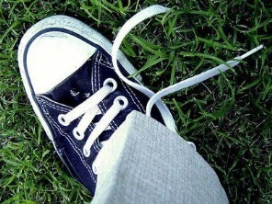
untied
unusual
unwanted
unwell
unwind
unzip

