1. Just add ‘ly’
bold + ly = boldly
brave + ly =
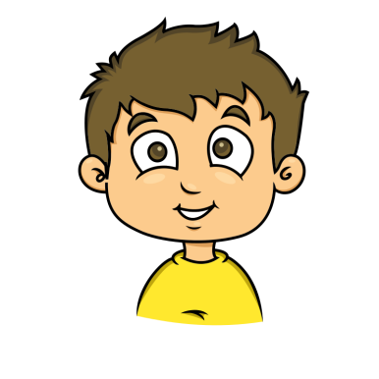
calm + ly =
clear + ly =
clever + ly =
dead + ly =
deep + ly =
exact + ly =
glad + ly =
1. Just add ‘ly’
hour + ly = hourly
keen + ly =
kind + ly =
live + ly =
loud + ly =

kind + ly =
main + ly =
most + ly =
neat + ly =
1. Just add ‘ly’
nice + ly = nicely
part + ly =
quick + ly =
quiet + ly =
real + ly =
rude + ly =
sad + ly =
silent + ly =
slow + ly =
1. Just add ‘ly’
soft + ly = softly
swift + ly =
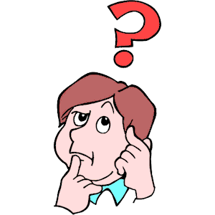
usual + ly =
week + ly =
wild + ly =
year + ly =
slow + ly =
sudden + ly =
tight + ly =
1. Just add ‘ly’
beautiful + ly =
cheerful + ly =
graceful + ly =
helpful + ly =
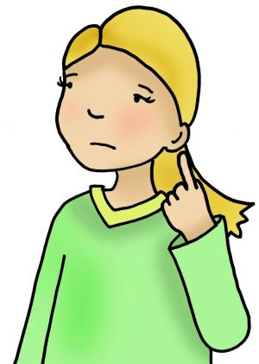
hopeful + ly =
painful + ly =
peaceful + ly =
playful + ly =
thankful + ly =

