# **Y6 Tests**

# **R4b. Can accurately and selectively summarise main ideas, events and information from non-fiction**

**Skills Test 1**

**Commissioned by The PiXL Club Ltd.**

**May 2019**

**This resource is strictly for the use of member schools for as long as they remain members of The PiXL Club. It may not be copied, sold nor transferred to a third party or used by the school after membership ceases. Until such time it may be freely used within the member school.**

**All opinions and contributions are those of the authors. The contents of this resource are not connected with nor endorsed by any other company, organisation or institution.**

**PiXL Club Ltd endeavour to trace and contact copyright owners. If there are any inadvertent omissions or errors in the acknowledgements or usage, this is unintended and PiXL will remedy these on written notification.**

© Copyright The PiXL Club Limited, 2019

**4b. Can accurately and selectively summarise main ideas, events and information from non-fiction**

**Skills Test 1**

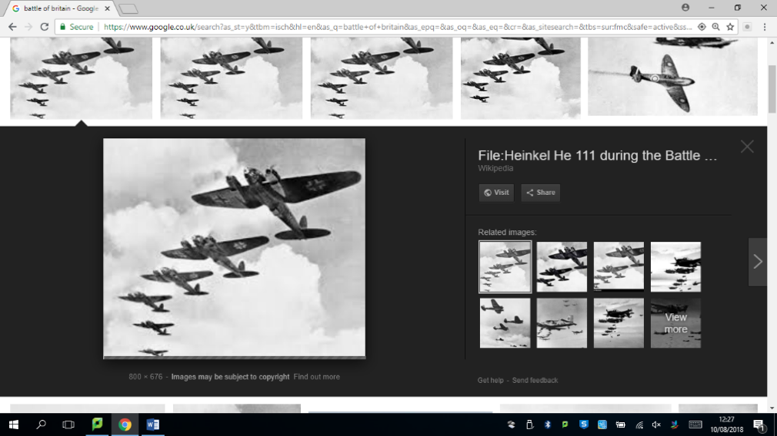*Read the text and answer the questions below. Use the spaces provided to write your answers or put a tick or number in the correct box.*

**World War II Events**

Even though World War II involved countries from all over the world, there were two sides fighting against each other – the Axis powers and the Allied powers. The main **Axis** countries were Germany, Italy and Japan. The main **Allied** countries were Great Britain, the United States, France and the Soviet Union. There were many battles during World War II, but the three below were some of the biggest.

**The Siege of Leningrad**

The city of Leningrad in Russia was laid siege to by the German Military for 900 days – from 8 September 1941 to 27 January 1944. Everyone inside the city was trapped; it was impossible for food or other supplies such as medical resources to get in. Hundreds of thousands of people died during this time (approximately 800,000) – they either starved to death or froze due to lack of food provisions and heat.

**Dunkirk**

In 1940, Hitler’s armies bombed Dunkirk and many Allied troops were waiting on the beach to be rescued because they didn’t have the resources they needed to defend themselves. From 26 May to 4 June, over 550,000 troops were ferried to safety across the English Channel – the code name for this was ‘Operation Dynamo’. Some British civilians (people who weren’t in the army) even used their own boats to help save as many people as they could.

**The Battle of Britain**

The Battle of Britain was the first military battle to be fought entirely in the air. Britain’s RAF (Royal Air Force) overpowered Germany’s Luftwaffe, after a long series of battles from 10 July-31 October 1940. It was named the Battle of Britain as it is believed that it made Hitler change his mind about trying to invade the UK. The RAF pilots showed tremendous courage as they kept fighting the Luftwaffe even when it looked as if they might be defeated.

*.*

1. Look at the first paragraph. Which of the below **best** summarises the paragraph?

Tick **one**

The battles of World War II

Who fought in World War II

How World War II started

An introduction to World War II

2. Summarise the key events from the text in your own words using the box below.

___________________________________________________________________________________________

___________________________________________________________________________________________

___________________________________________________________________________________________

___________________________________________________________________________________________

___________________________________________________________________________________________

1. Which of the below would be the **most** suitable summary of the whole text?

Tick **one**

Information about some of the events of World War II

A step by step guide to all World War II events

An explanation about how the Allies won the war

A chronological report on World War II events

**4b. Can accurately and selectively summarise main ideas, events and information from non-fiction**

**Answers:**

1. Who fought in World War II
2. Summaries should include who fought on each side and then brief sentences/bullet points about each event – e.g. :

* Axis – Germany, Italy and Japan
* Allies – Great Britain, France, United States, Soviet Union
* Siege of Leningrad – in Russia, about 800,000 died due to starvation and cold as they were trapped by German troops.
* Dunkirk – bombed Allied troops waiting on beaches to be rescued; 550,000 troops taken to safety, some in civilian boats.
* The Battle of Britain – first military battle fought only in the air. Britain’s RAF overpowered the German Luftwaffe.

1. Information about some of the events in World War II