# **Y6 Tests**

# **R4c. Can identify key details and use quotes for illustration**

**Skills Test 1**

**Commissioned by The PiXL Club Ltd.**

**May 2019**

**This resource is strictly for the use of member schools for as long as they remain members of The PiXL Club. It may not be copied, sold nor transferred to a third party or used by the school after membership ceases. Until such time it may be freely used within the member school.**

**All opinions and contributions are those of the authors. The contents of this resource are not connected with nor endorsed by any other company, organisation or institution.**

**PiXL Club Ltd endeavour to trace and contact copyright owners. If there are any inadvertent omissions or errors in the acknowledgements or usage, this is unintended and PiXL will remedy these on written notification.**

© Copyright The PiXL Club Limited, 2019

**4c. Can identify key details and use quotes for illustration**

**Skills Test 1**

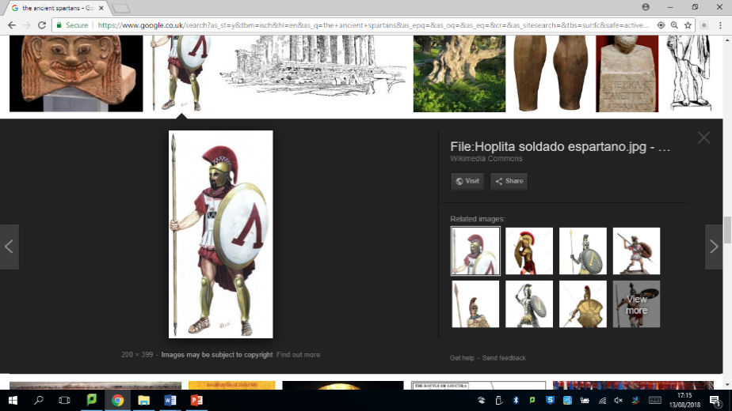*Read the text and answer the questions below. Use the spaces provided to write your answers or put a tick or number in the correct box.*

**The Spartans**

Of all the ancient civilisations, the most disciplined was that of the Spartans. At the height of their power, they had established a strict society built on a system of loyalty, military service and education. Everyone was expected to be taught maths, reading and writing – even the girls, which was unusual in those days – and each boy was destined to become a soldier. This meant that, while the lads were spending their time being turned into perfect physical specimens, all the actual work had to be done by slaves. They were treated appallingly to stop them from rising up against their cruel masters.

1. List six key points from the text.

* _______________________________________________________________
* _______________________________________________________________
* _______________________________________________________________
* _______________________________________________________________
* _______________________________________________________________
* _______________________________________________________________

1. One key point about the Spartans is that they did not treat their slaves well. What evidence is there in the text as to why they did this?

_____________________________________________________________________

_____________________________________________________________________

1. Use a quote from the text as evidence for **one** of your other key points.

Key point: ___________________________________________________________

Quote: ______________________________________________________________

_______________________________________________________________

_______________________________________________________________

**4c. Can identify key details and use quotes for illustration**

**Answers:**

* Disciplined civilisation
* Strict society built on loyalty, military service and education
* Everyone taught reading and writing
* Boys destined to become soldiers
* Slaves did all the work
* Slaves treated badly to stop them rising up against their masters

1. They were treated appallingly to stop them from rising up against their cruel masters.
2. Accept any quote which backs up a key point.