# **Y6 Tests**

# **R4d. Can accurately order summaries of different paragraphs within a text**

**Skills Test 1**

**Commissioned by The PiXL Club Ltd.**

**May 2019**

**This resource is strictly for the use of member schools for as long as they remain members of The PiXL Club. It may not be copied, sold nor transferred to a third party or used by the school after membership ceases. Until such time it may be freely used within the member school.**

**All opinions and contributions are those of the authors. The contents of this resource are not connected with nor endorsed by any other company, organisation or institution.**

**PiXL Club Ltd endeavour to trace and contact copyright owners. If there are any inadvertent omissions or errors in the acknowledgements or usage, this is unintended and PiXL will remedy these on written notification.**

© Copyright The PiXL Club Limited, 2019

**R4d. Can accurately order summaries of different paragraphs within a text**

**Skills Test 1**

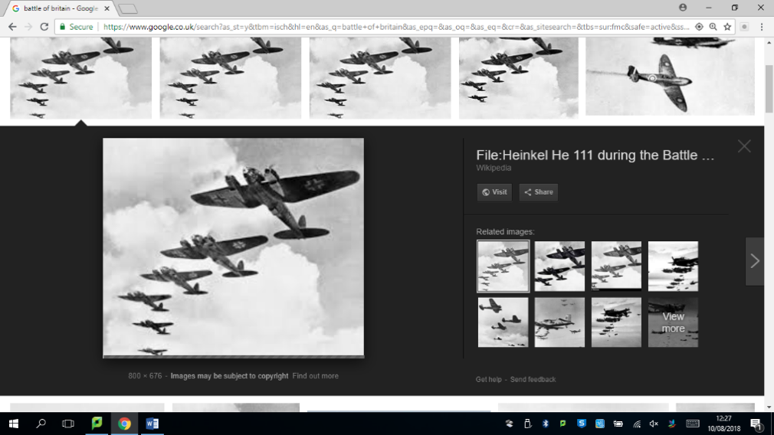*Read the text and answer the questions below. Use the spaces provided to write your answers or put a tick or number in the correct box***.**

**World War II Events**

Even though World War II involved countries from all over the world, there were two sides fighting against each other – the Axis powers and the Allied powers. The main **Axis** countries were Germany, Italy and Japan. The main **Allied** countries were Great Britain, the United States, France and the Soviet Union. There were many battles during World War II, but the three below were some of the biggest.

**The Siege of Leningrad**

The city of Leningrad in Russia was laid siege to by the German Military for 900 days – from 8 September 1941 to 27 January 1944. Everyone inside the city was trapped; it was impossible for food or other supplies such as medical resources to get in. Hundreds of thousands of people died during this time (approximately 800,000) – they either starved to death or froze due to lack of food provisions and heat.

**Dunkirk**

In 1940, Hitler’s armies bombed Dunkirk and many Allied troops were waiting on the beach to be rescued because they didn’t have the resources they needed to defend themselves. From 26 May to 4 June, over 550,000 troops were ferried to safety across the English Channel – the code name for this was ‘Operation Dynamo’. Some British civilians (people who weren’t in the army) even used their own boats to help save as many people as they could.

**The Battle of Britain**

The Battle of Britain was the first military battle to be fought entirely in the air. Britain’s RAF (Royal Air Force) overpowered Germany’s Luftwaffe, after a long series of battles from 10 July-31 October 1940. It was named the Battle of Britain as it is believed it made Hitler change his mind about trying to invade the UK. The RAF pilots showed tremendous courage as they kept fighting the Luftwaffe even when it looked as if they might be defeated.

*.*

1. Below are some summaries of different paragraphs from the text. Number them 1-5 to show the order in which they appear in the text. One has been done for you.

Some of Britain’s troops were ferried to safety from the beaches.

Different nations were involved in World War II.

1

The RAF defeated the German bombers.

The German army attacked Dunkirk.

Many people were imprisoned in their own city by German troops.

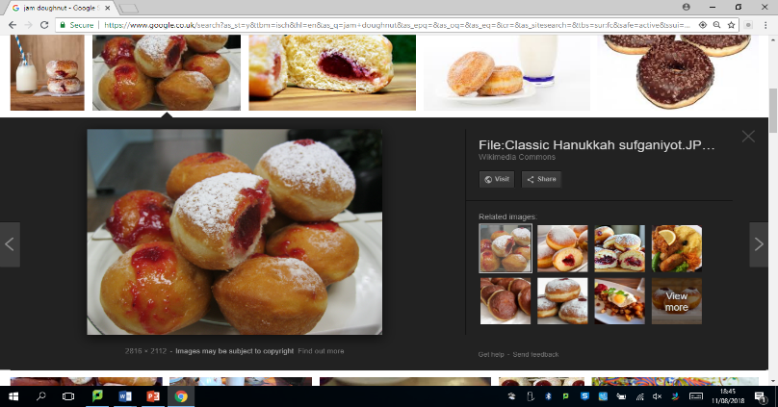

**The Great Doughnut Race**

A large crowd gathered around the enormous trestle table which was covered in a red and white checked tablecloth and held a variety of gargantuan dishes towering with sugary, sticky jam doughnuts.

Jonathan gulped; he had been waiting for this day ever since last year’s doughnut-eating contest, when he had embarrassed himself by only managing four, but this year he had practised. OK, his jeans were feeling rather tight and his t-shirts were also snug, but all of the practice would be worth it if he was victorious today. His hands felt sweaty and he could feel nerves creeping in; now was not the time to start feeling sick! He tried to focus on feeling hungry, reminding himself that he had had nothing to eat since the previous evening. He imagined his favourite food – hot, crispy roast potatoes and light and fluffy Yorkshire puddings and he began to salivate. He could do this!

Trying to calm his anticipation, he glanced around at the other contestants. They were laughing and fooling around with their friends; they clearly weren’t as bothered as he was, but he had far more to lose. He desperately needed to win in order to restore his reputation as the best eater in school and get back in with Jimbo and the gang. He couldn’t face another year of isolation and humiliation, hanging out with people he had nothing in common with. His thoughts were interrupted by a loudspeaker.

“And now Ladies and Gentlemen, boys and girls, we are ready for the event of the year, our annual doughnut-eating contest!”

Whoops and cheers came from the crowd and, as he soaked up the atmosphere, he caught Jimbo’s eye. He was smirking at Jonathan and so were all of the others.

“Here goes nothing!” Jonathan thought.

A hush fell over the crowd as the referee approached. One by one she examined the plates of doughnuts and declared that they were all equal in size and all contained adequate amounts of jam.

“Contestants, take your places please!” yelled the red-faced judge, puffing for breath as she hurried towards the table.

1. Number the following sentences from 1-5 to show the order in which they happen in the text. One has been done for you.

The referee checks that the contest is fair.

People come to watch the contest.

1

Jonathan imagines his favourite food to calm his nerves.

Jonathan realises that Jimbo is watching him.

Jonathan remembers this time last year.

**4d. Can accurately order summaries of different paragraphs within a text**

**Answers:**



Some of Britain’s troops were ferried to safety from the beaches.

4

Different nations were involved in World War II.

1

The RAF defeated the German bombers.

5

The German army attacked Dunkirk.

3

Many people were imprisoned in their own city by German troops.

2



The referee checks that the contest is fair.

5

People come to watch the contest.

1

Jonathan imagines his favourite food to calm his nerves.

3

Jonathan realises that Jimbo is watching him.

4

Jonathan remembers this time last year.

2