# **R4e. Can identify the main message in a poem/story**

**Commissioned by The PiXL Club Ltd.**

**May 2019**

**This resource is strictly for the use of member schools for as long as they remain members of The PiXL Club. It may not be copied, sold nor transferred to a third party or used by the school after membership ceases. Until such time it may be freely used within the member school.**

**All opinions and contributions are those of the authors. The contents of this resource are not connected with nor endorsed by any other company, organisation or institution.**

**PiXL Club Ltd endeavour to trace and contact copyright owners. If there are any inadvertent omissions or errors in the acknowledgements or usage, this is unintended and PiXL will remedy these on written notification.**

© Copyright The PiXL Club Limited, 2019

**4e. Can identify the main message in a poem or a story**

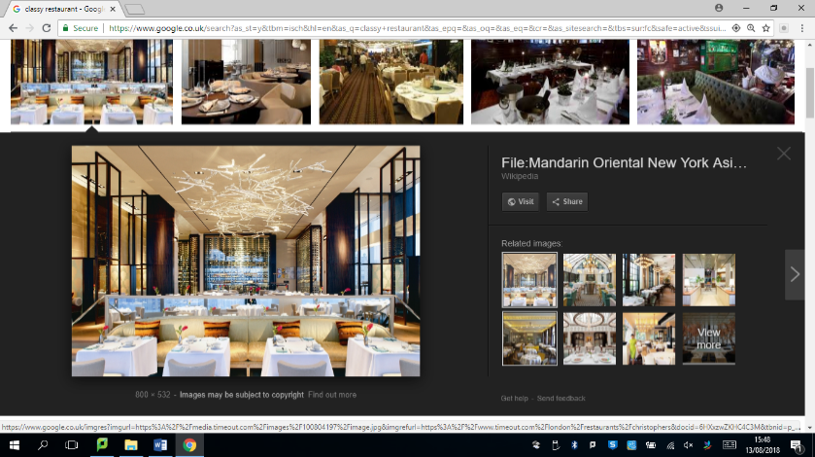*Read the text and answer the questions below. Use the spaces provided to write your answers or put a tick or number in the correct box.*

**The Restaurant**

Bethany’s stomach was rumbling. Here she was, sitting in this brand-new, classy restaurant that everyone had said was so marvellous, and yet no one had even come over to her table to take her order. Not wanting to embarrass herself, she sat quietly, hoping to catch the eye of one of the waiters. No such luck. They all seemed to be too busy bursting in and out of the doors to the kitchen, or talking to customers who had already been served. Worse still, she could hear them exaggerating their fake foreign accents in a desperate attempt to impress the customers. Bethany looked around at the shiny, polished room; she could see other people becoming agitated as they had been waiting as long as, or longer than she had. At least she wasn’t the only one. She was beginning to think that everyone had got it wrong and the restaurant was not so marvellous after all. Bethany knew that in life things often didn’t live up to expectations.

1. What is the **main** message in this text?

Use evidence from the text to support your answer.

___________________________________________________________________

___________________________________________________________________

___________________________________________________________________

___________________________________________________________________

**Good and Bad Children – Robert Louis Stevenson**

Children, you are very little,   
And your bones are very brittle;   
If you would grow great and stately,   
You must try to walk sedately.   
  
You must still be bright and quiet,   
And content with simple diet;   
And remain, through all bewild'ring,   
Innocent and honest children.   
  
Happy hearts and happy faces,   
Happy play in grassy places--   
That was how in ancient ages,   
Children grew to kings and sages.   
  
But the unkind and the unruly,   
And the sort who eat unduly,   
They must never hope for glory--   
Theirs is quite a different story!   
  
Cruel children, crying babies,   
All grow up as geese and gabies,   
Hated, as their age increases,   
By their nephews and their nieces.

* sages – wise men

* gabies – fools

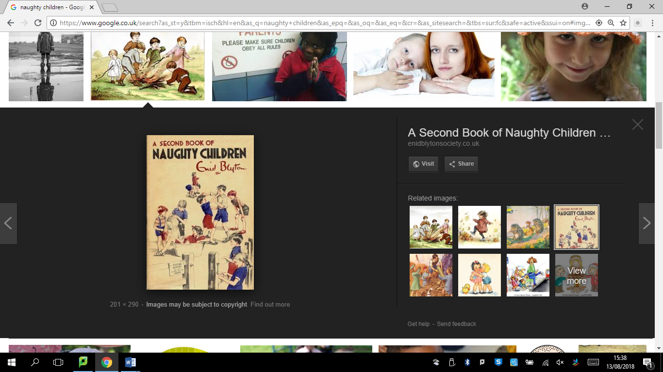

2.

a) What is the **main** message in this poem? Tick **one**.

Children must be happy all of the time.

Bad children are foolish.

You must walk slowly and calmly if you are to grow up to be great and

important.

Good children grow up to be important and wise and bad children grow up to

be foolish and disliked.

b) Explain your answer using evidence from the text.

___________________________________________________________________

___________________________________________________________________

___________________________________________________________________

**4e. Can identify the main message in a poem or story**

**Answers:**

1. The restaurant was not as good as people said it was/the restaurant did not live up to expectations.

Acceptable points from the text:

* Bethany was kept waiting
* Waiters were too busy
* Waiters were talking to people that had already been served
* Exaggerated fake foreign accents, desperate to impress
* Other customers agitated/other customers also waiting

1. a) Good children grow up to be important and wise and bad children grow up to be foolish and disliked.

b)

* + It says ‘That was how in ancient ages, Children grew to kings and sages.’
  + It says ‘Cruel children, crying babies, all grow up as geese and gabies’ and gabies means fools.
  + It says ‘Hated as their age increases, By their nephews and their nieces.’
  + It says ‘But the unkind and the unruly, And the sort who eat unduly, They must never hope for glory.’