# **Y6 Test**

# **R4f. Can use information from the whole text to answer questions – e.g. true or false**

# **Skills Test 1**

**Commissioned by The PiXL Club Ltd.**

**May 2019**

**This resource is strictly for the use of member schools for as long as they remain members of The PiXL Club. It may not be copied, sold nor transferred to a third party or used by the school after membership ceases. Until such time it may be freely used within the member school.**

**All opinions and contributions are those of the authors. The contents of this resource are not connected with nor endorsed by any other company, organisation or institution.**

**PiXL Club Ltd endeavour to trace and contact copyright owners. If there are any inadvertent omissions or errors in the acknowledgements or usage, this is unintended and PiXL will remedy these on written notification.**

© Copyright The PiXL Club Limited, 2019

**R4f. Can use information from the whole text to answer questions – e.g. true or false**

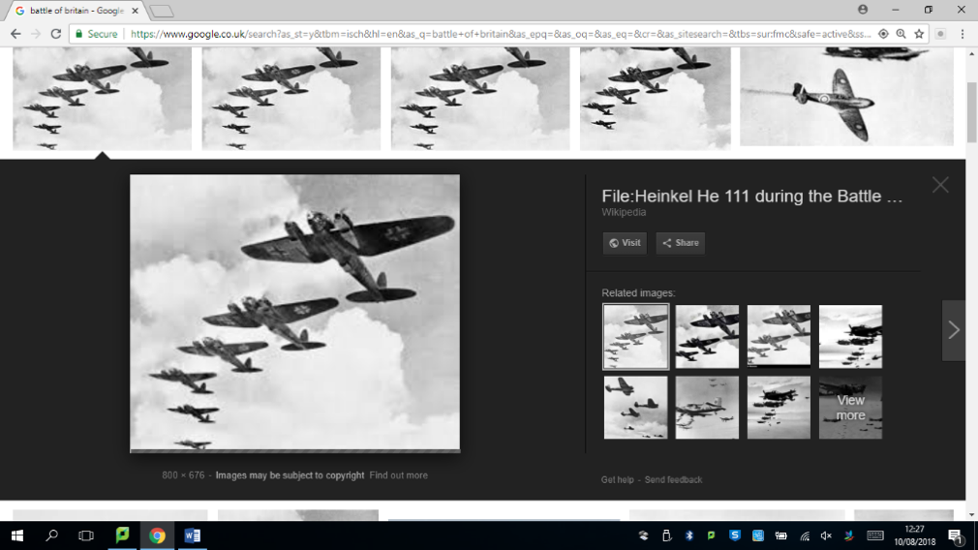*Read the text and answer the questions below. Use the spaces provided to write your answers or put a tick or number in the correct box.*

**World War II Events**

Even though World War II involved countries from all over the world, there were two sides fighting against each other – the Axis powers and the Allied powers. The main **Axis** countries were Germany, Italy and Japan. The main **Allied** countries were Great Britain, the United States, France and the Soviet Union. There were many battles during World War II, but the three below were some of the biggest.

**The Siege of Leningrad**

The city of Leningrad in Russia was laid siege to by the German Military for 900 days – from 8 September 1941 to 27 January 1944. Everyone inside the city was trapped; it was impossible for food or other supplies such as medical resources to get in. Hundreds of thousands of people died during this time (approximately 800,000) – they either starved to death or froze due to lack of food provisions and heat.

**Dunkirk**

In 1940, Hitler’s armies bombed Dunkirk and many Allied troops were waiting on the beach to be rescued because they didn’t have the resources they needed to defend themselves. From 26 May to 4 June, over 550,000 troops were ferried to safety across the English Channel – the code name for this was ‘Operation Dynamo’. Some British civilians (people who weren’t in the army) even used their own boats to help save as many people as they could.

**The Battle of Britain**

The Battle of Britain was the first military battle to be fought entirely in the air. Britain’s RAF (Royal Air Force) overpowered Germany’s Luftwaffe, after a long series of battles from 10 July-31 October 1940. It was named the Battle of Britain as it is believed it made Hitler change his mind about trying to invade the UK. The RAF pilots showed tremendous courage as they kept fighting the Luftwaffe even when it looked as if they might be defeated.

1. Using information from the whole text, put a tick in the correct box to show whether each statement is **true** or **false**.

|  |  |  |
| --- | --- | --- |
|  | **True** | **False** |
| Italy was part of the Axis and fought against Great Britain. |  |  |
| Hundreds of thousands of people lost their lives in Leningrad due to a lack of food and warmth. |  |  |
| In the battle of Dunkirk, Allied forces could not fight back as they did not have the necessary weapons. |  |  |
| The Battle of Britain encouraged Hitler to invade the United Kingdom. |  |  |

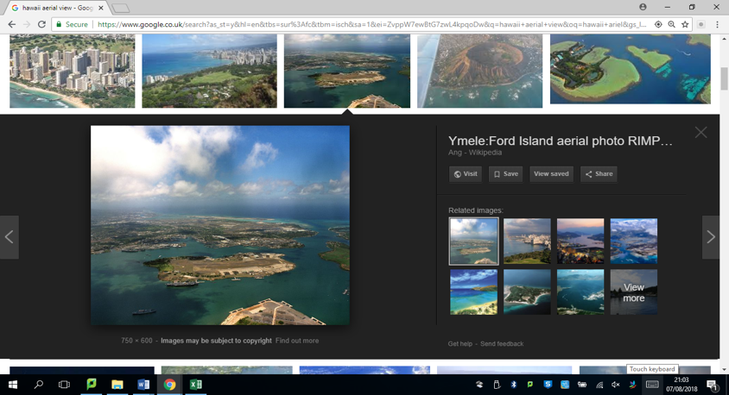

**Hawaii**

Hawaii is the 50th state to join the United States of America; it is also the most recent state to join. It is the only U.S. state that is composed entirely of islands. The word Hawaii means ‘place of the gods’ or ‘homeland’. Hawaii was originally called the Sandwich Isles which is what Captain James. C. Cook named the islands in 1778 in honour of the person who sponsored his travels, the Earl of Sandwich.

Hawaii is made up of 132 islands – eight main islands (Hawaii, Maui, Oahu, Kauai, Molokai, Lanai, Nihau and Kahoolawe) and 124 islets (small islands) and reefs (a ridge of jagged rock, coral or sand just above or below the surface of the sea). The Hawaiian islands are the tops of the world’s biggest mountain range. Under-sea volcanoes that erupted millions of years ago formed the islands of Hawaii.

Only two types of mammal are native to Hawaii – the hoary bat and the monk seal. The rest of the animals were brought there by people migrating to the islands.

1. Using information from the whole text, put a tick in the correct box to show whether each statement is **true** or **false**.

|  |  |  |
| --- | --- | --- |
|  | **True** | **False** |
| Hawaii was the earliest state to join the United States of America. |  |  |
| Hawaii was first discovered by the Earl of Sandwich. |  |  |
| The islands of Hawaii are made from dormant volcanoes. |  |  |
| Very few animals are originally from Hawaii. |  |  |

**4f. Can use information from the whole text to answer questions – e.g. true or false**

**Answers:**

1. True

True

True

False

1. False

False

True

True