16th October 2024

Dear Parent/Carers

**TERM 2 AFTER SCHOOL CLUBS**

From Monday 4th November 2024 until Friday 13th December we will be running the following After School Clubs. Please note due to rising costs we have had to increase our charges.

|  |  |  |  |  |  |
| --- | --- | --- | --- | --- | --- |
| TERM 2 | | | | | |
| Name of Club | Adult Lead | Key Stage | Day | Time | Cost Per Term |
| Multi-Skills Club | Mr. Amos | EYFS and Year 1 | Mondays | 3:15-4:15 pm | £18.00 |
| Netball Club | Mrs. Hawks | Years 5 & Year 6 | Mondays | 3:15- 4:15 pm | £18.00 |
| Dove Club | All Saints Church Group | Years 3 to Year 6 | Tuesdays | 3:15-4.15 pm | No charge |
| Kingsquad | Family Trust Church | Years 3 to Year 6 | Wednesdays | 3:15-4:15 pm | No charge |
| Colouring Club | Miss Taylor | Year 1 and Year 2 | Thursdays | 3:15-4:15 pm | £18.00 |
| Athletics | Mr. Amos | Year 1 and Year 2 | Thursdays | 3:15-4:15 pm | £18.00 |
| Tennis Club | Mr. Amos | Year 3 to Year 6 | Friday | 3:15-4:15 pm | £18.00 |
|  |  |  |  |  |  |
|  |  |  |  |  |  |

**Due to Parent’s Evening on 19th November and 20th November After School Clubs will be cancelled on these days**

**The above Clubs must now be booked directly through your MyChildAtSchool app under “Products” and must be paid for in advance. If payment is not made your child will be unable to attend the club. However, please do not let the cost prevent you from applying for a place. Speak with either myself or Mrs Gooding in the strictest of confidence.**

Non-chargeable Clubs can be booked in the normal way on your MyChildAtSchool app under “Clubs”. These clubs are Dove Club and Kingsquad. Unfortunately Choir Club is fully booked.

**By signing up to any of the above clubs you are agreeing for staff to give consent on your behalf for an anaesthetic and/or blood transfusion to be administered or any other urgent medical treatment to be given should the need arise, if you cannot be contacted in the first instance.**

**Kind regards**

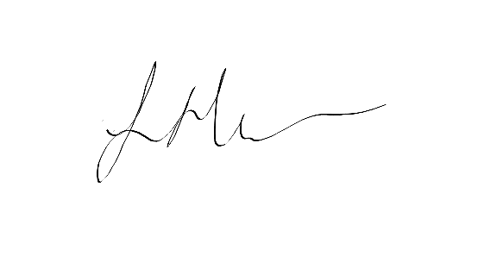

Mrs S Heather – Headteacher