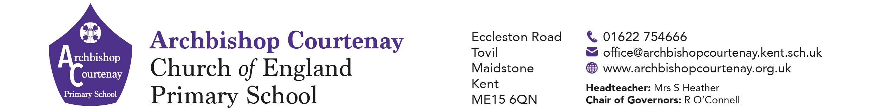

31st January 2025

Dear Parents and Carers

**The Kensington Palace London Trip on Thursday 6th March 2025**

We are delighted to inform you that Lower Key Stage Two will be visiting Kensington Palace **on Thursday 6th March** **2025**.

We will be travelling to London by Coach, leaving school promptly by 7.30 am. We would ask that children arrive at school **no later than 7.15 am** to enable us to register them and complete pre-trip checks.

All children will require a large packed lunch for the day with bottles that can be refilled and in packaging that can be thrown away once they have eaten. If your child would like a school packed lunch please complete the form below. School uniform is to be worn with a waterproof coat and sensible shoes.

The children will arrive at the Palace and split into adult led groups before regrouping for their timed workshops and lunch. They will be expected to follow the behaviour and safety expectations of both the school and the Palace whilst on the trip.

We will be leaving the Palace at 3.00 pm to travel back to school and will anticipate arriving back at school by 4.30 pm – this will however be subject to traffic. Staff on the trip will keep the school office team updated on the journey and ETA which should be no later than 5pm.

The cost of the trip is **£16.90** per child and this includes coach travel and workshop costs which you may have already paid through Products in your My Child At School app. *We are also happy for parents to pay in instalments.*

If you are experiencing financial difficulties please come and speak to Mrs Gooding or Mrs Heather who may be able to offer additional support for your family.

We are looking forward to taking the children to London but if we do not receive enough contributions for travel costs the trip may have to be cancelled.

Mrs. M. Hawks and the Lower Key Stage 2 Team

-----------------------------------------------------------------------------------------------------------------------------------

**LKS2 Kensington Palace London Trip Thursday 6th March 2025**

I give permission for my child: in class to attend the above trip.

My child will need a school packed lunch TUNA or CHEESE (please circle)

I give permission for the adults in charge to administer first aid and act in loco parentis should a medical emergency happen.

My child has the following medical conditions / allergies: _____ ___________

Emergency contact name: _______ Emergency contact number: _____