February 2025
Dear Parent/Carers
TERM 4 AFTER SCHOOL CLUBS
From Monday 24th February 2025 until Friday 4th April 2025 we will be running the following After School Clubs. Please note due to rising costs we have had to charge for some Clubs.
TERM 4
Name of Club | Adult Lead | Key Stage | Day | Time | Cost Per Term
Gardening Club | Miss Copley | Years 2,3,4,5, & 6 | Mondays | 3:15-4:15 pm | £18.00
Netball Club | Mrs. Hawks | Years 4, 5 & Year 6 | Mondays | 3:15- 4:15 pm | No charge
Choir Club | Mrs. Smith | Years 3,4,5 & 6 | Tuesdays | 3:15-4:15 pm | No charge
Dove Club | All Saints Church Group | Years 3, 4,5 & 6 | Tuesdays | 3:15-4.15 pm | No charge
Kingsquad | Family Trust Church | Years 3,4,5, & 6 | Wednesdays | 3:15-4:15 pm | No charge

Gardening Club must be booked directly through your MyChildAtSchool app under “Products” and must be paid for in advance. If payment is not made your child will be unable to attend the club. However, please do not let the cost prevent you from applying for a place. Speak with either myself or Mrs Gooding in the strictest of confidence.
Non-chargeable Clubs can be booked in the normal way on your MyChildAtSchool app under “Clubs”. These clubs are Choir Club, Dove Club, Kingsquad and Netball Club.
By signing up to any of the above clubs you are agreeing for staff to give consent on your behalf for an anaesthetic and/or blood transfusion to be administered or any other urgent medical treatment to be given should the need arise, if you cannot be contacted in the first instance.
Kind regards
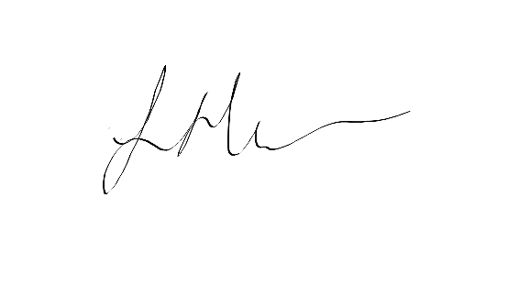
Mrs S Heather – Headteacher

