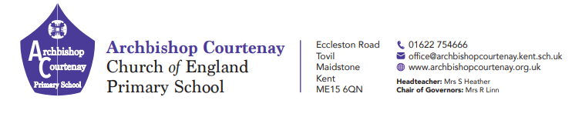
Wednesday 2nd September ^{th}

20th March 2025
PGL Trip to Windmill Hill 16th May to the 19th May 2025
Dear Parents and Carers
I expect all of your children are getting excited about our residential trip in May
Please see below a list of the items that they will need to bring with them -
Bedding – a pillow, a duvet or a sleeping bag
Washing bag – soap, shampoo, toothbrush and toothpaste, deodorant (No aerosols)
Tops and Jackets
Trousers, Leggings and Shorts
Underwear and ankle socks
1 or 2 sets of clothes for the evenings.
Suitable nightwear
Hat and Sun Cream
2 pairs of trainers – 1 for activities and an old pair for water sports
1 pair of shoes for evening activities
2 towels
Reusable drinks bottle
Small rucksack/bag
Labelled black sack for wet and dirty clothes
Torch
NO MOBILES OR ELECTRONIC DEVICES
Also attached are three forms, one for photograph permission, one if your child requires any medicine whilst away and one with your contact details and the accident permission. Please ensure all forms are returned to the office by Monday 12th May 2025.
Thank you
Kind regards
Mr M Biddlecombe, Mrs M Hawks and Mrs L Green

