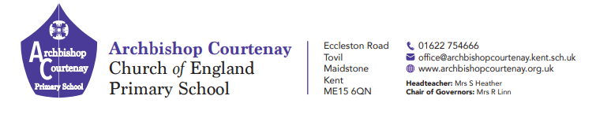
Wednesday 2nd September
26th

20th March 2025
PGL Trip to Windmill Hill Friday 16th May to Monday 19th May 2025
Dear Parents and Carers
I expect all of your children are getting excited about our residential trip next month.
Please see below further details -
All children need to arrive at school for 1.15pm
If your child needs to take medication over the weekend away please complete the attached medical form and return to school by Friday 10th May. All medicines must be handed to the designated member of staff in a named clear plastic wallet/bag on the day of departure.
Please ensure that your child does not bring any valuables with them and no more than £10 spending money.
Your child will need collecting at 3.30pm on the Monday. Updates will be sent to you via MCAS regarding delays due to traffic.
If there is an emergency you can contact the Windmill Hill Centre on 01323 834680 or 07525226239. THIS IS FOR EMERGENCIES ONLY AND NOT FOR CHECKING ON YOUR CHILD.
All children who have attended the PGL residential trip are not expected to attend school on Tuesday 20th May 2025,
Attached to this letter is also a contact form with the accident permission and a photograph permission form which need to be completed and signed.
NO MOBILES OR ELECTRONIC DEVICES ARE ALLOWED
Kind regards
Mark Biddlecombe

