Year 2

Diagnostic Tasks for Measurement
Priority Statements

Commissioned by The PiXL Club Ltd.
October 2019
This resource is strictly for the use of member schools for as long as they remain members of The PiXL Club. It may not be copied, sold nor transferred to a third party or used by the school after membership ceases. Until such time it may be freely used within the member school.
All opinions and contributions are those of the authors. The contents of this resource are not connected with nor endorsed by any other company, organisation or institution.
PiXL Club Ltd endeavour to trace and contact copyright owners. If there are any inadvertent omissions or errors in the acknowledgements or usage, this is unintended and PiXL will remedy these on written notification.

© Copyright The PiXL Club Limited, 2019
Teacher Guidance
This resource is designed to use with pupils who are being targeted to achieve the expected standard in mathematics at the end of Year 2. It will support teachers in diagnosing gaps in pupils’ mathematical skills, knowledge and understanding related to measurement. It is important to note that the diagnostic tasks focus only on the priority statements for this content domain: addressing these is likely to have the most impact on future learning.
There is no expectation for it to be used in its entirety in one sitting or as a formal test situation. Rather, teachers should adopt a more flexible format which allows a pupil’s responses to inform the lines of questioning as and when appropriate. This will help support teachers in identifying barriers which may be the problem type, question type, vocabulary or conceptual understanding.
- All the questions can be read to pupils (you can read words and numbers, but not mathematical symbols).
- Pupils should be provided with a range of practical resources, from which they can choose, to support their approach to these questions where necessary.
- Pupils should also be encouraged to use drawings/jottings to help solve problems.
- Where appropriate, pupils may complete the questions independently from the selected part of the test paper to practise reading and attempting questions in this format. However, for some pupils you may wish to work through the questions with them one-to- one or in a small group.
- Ensure pupils have some understanding of the key mathematical language for each strand.
- Starred questions ( ) are intended to challenge deeper thinking and could be used specifically with A2/A1 pupils.
- The range of question types and the percentage of in-context questions reflect the proportionality in the end of KS1 expectations and assessment.
Components:
- Copy of the questions from the test; guidance for delivering the task; probing questions to enable you to consider what gaps, barriers or misconceptions pupils may have as well as recommended supporting resources which can be used to address these gaps.
- Diagnostic Test
QLA
PLC
Diagnostic Task
Digging deeper

Y2 M5a. Can choose and use appropriate standard units to measure length and height (m/cm using rulers, metre sticks, tape measure etc.).
Questions:
- Tick one box in each row to show whether the statement is true or false.
Statement | True | False
Length is the distance from end to end.
You can use a jug to measure length.
The units of measure for length are metres (m) and centimetres (cm).

- Match the most suitable equipment and unit of measure for the items below.
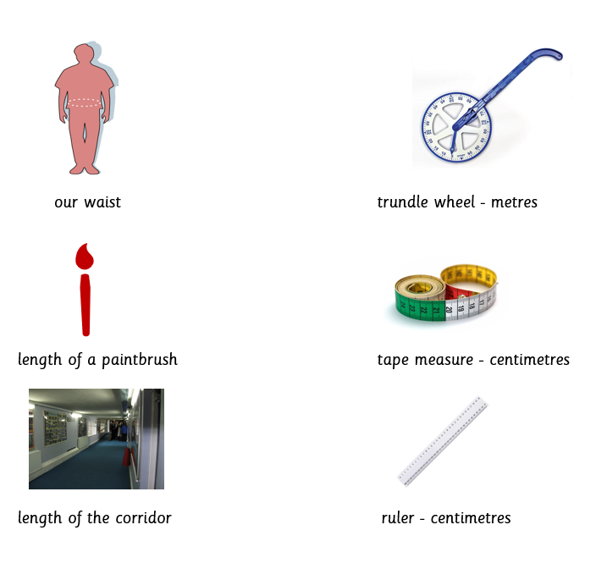

- Measure the height of this lamp to the nearest centimetre (cm).


- Zac has measured the width of his tablet. He says it is 5m wide. Is he correct? Explain your answer.


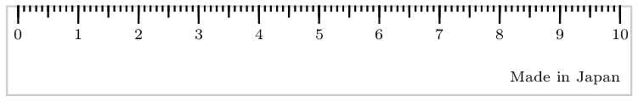
cm

Teacher guidance:
- Look out for pupils’ security of language in each of the statements.
- If possible, have examples of the equipment that pupils can explore. Point to other items around the classroom and ask what unit of measurement and equipment would be the most appropriate to measure the length, height or width with.
- Look out for pupils using the ruler correctly.
- If needed, prompt that there are two reasons to support their answer.

Vocabulary:
- measure, length, width, height, metres, centimetres, ruler, tape measure, trundle wheel, metre stick, nearest

Probing questions:
- Will the trundle wheel be appropriate to measure the height of the door? What equipment would you recommend for this task?
- Why is a ruler not suitable to measure our waist?
- What is the name of this measuring tool?
- How can we work out how wide Zac’s tablet is?

Supporting resources:
Y2 therapy M5a
Mathematics Recall Cards

Teacher notes:

Y2 M5e. Can compare and order two or more different measurements (length, mass, temperature or capacity/volume).
Questions:
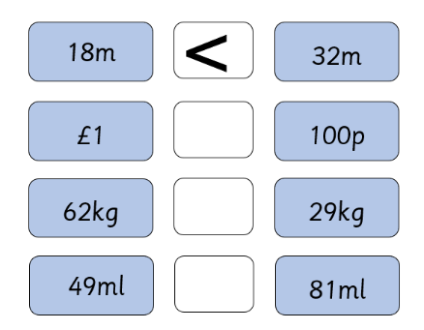
- Use <, > or = to compare these measures. The first one has been done for you.

- Sort these test tubes from least full to most full.
A
B
C
D

- Where is it the warmest?
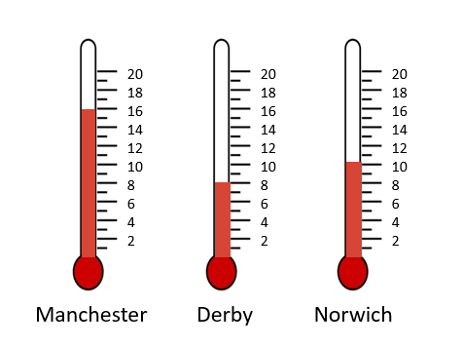

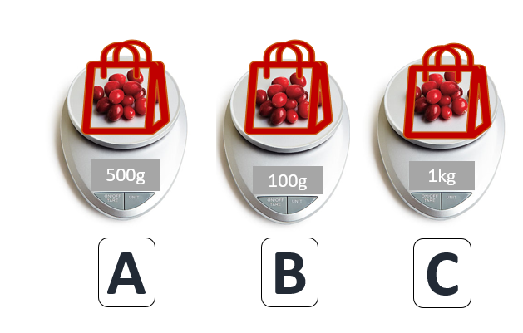
8. Which bag of cranberries is the heaviest? How much heavier is bag A than bag B?
g

Teacher guidance:
- Ensure pupils understand the inequality signs. Look out for security in the unit of measure being compared rather than just the numbers.
- Encourage pupils to use a ruler across the levels to check their answers.
- Look out for pupils knowing the unit of measure for temperature.
- Ensure pupils check the unit of measure on each scale.
Vocabulary:
- mass, length, weight, temperature, capacity, heaviest, lightest, tallest, shortest, compare, warmest, coldest, least, most

Probing questions:
- Can you tell me what measurements you are comparing?
- How do you know if something is lighter?
- How can you measure capacity?
- Can you tell me the unit of measure for temperature?
- If you had two 500g bags of cranberries on scale A, how would it compare to scale C?

Supporting resources:
Y2 therapy M5e
Mathematics Recall Cards

Teacher notes:

Y2 M5f. Can use the symbol p for pence and £ for pounds when combining amounts to make a particular value, e.g. 20p + 5p = 25p, £2 + £1 = £3.
Y2 M3g. Can solve simple problems in a practical context involving addition of money of the same unit.

Questions:
- What is the word for these symbols?
£ p
- Naz has 15p in her piggy bank. Give two possibilities of the coins that make this amount.
Write your answers as an addition calculation.


- Use <, > or = in the empty box to compare these amounts.
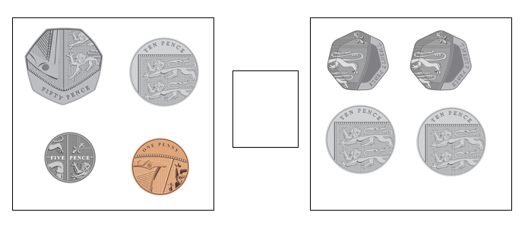

- Zac has saved his birthday money. He has £20 in notes in his wallet. Find all the possibilities of the notes he may have in his wallet.


Teacher guidance:
- If needed, explain that you want pupils to write the word that this symbol represents.
- Provide pupils with some play money to help them work out the different combinations.
- Look out for pupils who may not be confident with the value of the coins or with the addition.
- Encourage pupils to work systematically to ensure they find all the combinations.
For all the questions ensure pupils add the £ and p symbols and understand the importance of recording the unit of measure.

Vocabulary:
- coins, notes, value, pound, pence, change, combinations, systematic

Probing questions:
- How would you solve this?
- How does adding the symbol £ or p change the number?
- Which coin would you start with? Why?
- How can you be sure you have counted all the coins?
- What if we added £1? What would the total be?
- What if we took out the 20p coin? How much would there be?
- Would you jot anything down to help you?

Supporting resources:
Y2 therapy M5f
Y2 therapy M5g
Mathematics Recall Cards

Teacher notes:

Y2 M5f. Can use the symbol p for pence and £ for pounds when combining amounts to make a particular value, e.g. 20p + 5p = 25p, £2 + £1 = £3
Y2 3h. Can solve simple problems in a practical context involving subtraction of money of the same unit, including giving change including giving change.

Questions:
- Zac had £1 and he spent 50p. How much money does he have left? Circle the correct answer.
£1.50 51p 49p 50p
- Naz bought this book at the school fair. She gave the stallholder a 50p coin. How much change should she get back?
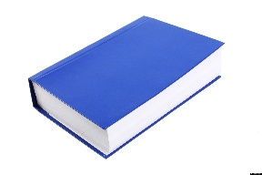


- Naz has 48p and Zac has 33p. How much more money does Naz have than Zac?

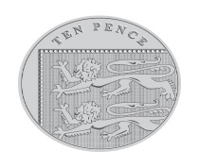
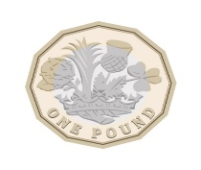
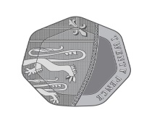
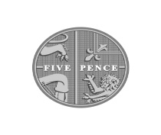
- Zac had these coins in his pocket. Two of the coins fell out. How much money was left in his pocket? Find three possibilities.

Teacher guidance:
- Look out for pupils who may ignore or not understand the symbols and knowing £1 = 100p.
- If needed, provide pupil with practical equipment or a number line to help them solve the subtraction.
- Some pupils may benefit from making the larger amount and then removing the coins for the amount they are subtracting.
- Encourage pupils to carefully record their different options, it may help to roughly draw the coins for each combination to ensure they do not duplicate a possibility.
For all the questions ensure pupils add the pound and pence symbols correctly and understand the importance of recording the unit of measure.
Vocabulary:
- coins, notes, value, pound, pence, change, combinations, systematic

Probing questions:
- How would you write out the number sentence for this calculation?
- How can you check your answer?
- What would the total of their money combined be?
- Would you jot anything down to help you?

Supporting resources:
Y2 therapy M5f
Y2 therapy M5h
Mathematics Recall Cards

Teacher notes:

