1. Star Project (see attached slides)
2. Using the numbers 1, 2, 3 and 4, make every number 1 to 30 using the four operations. You must use all of 1 2 3 4 (you can use them as powers)
3. 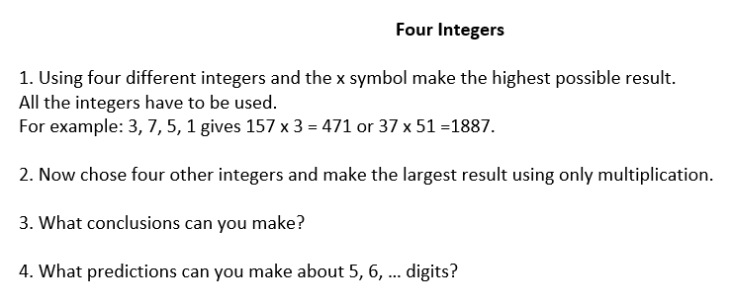
4. 