Tuesday 5th January 2021

Hopefully yesterday you will have received an email inviting you to join the ABC Virtual Learning Platform or TEAMS as it will be referred to. All work will be available through TEAMS and also on the school website for you. TEAMS will help us to teach LIVE lessons from the classroom and you can join in from home! The technology is very new to us all, so please show us compassion as we show resilience in getting things up and running for everyone.

Let’s warm up our bodies and brains

WAKE UP AND SHAKE UP or THE DAILY MILE

 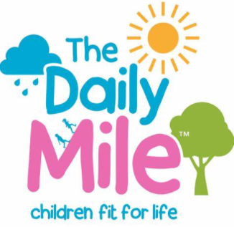

[Leeds Rhinos Foundation Wake up Shake Up 2017 - Bing video](https://www.bing.com/videos/search?q=wake+up+and+shake+up+youtube&docid=608032872745339336&mid=FBB4B071AC6F9B32003EFBB4B071AC6F9B32003E&view=detail&FORM=VIRE)

MATHS

We will begin Term 3 by reviewing our knowledge and understanding of Number and Place Value as this must be secure to help us with all other areas of mathematics.

WARM UP:

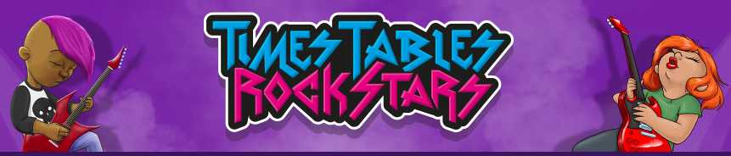 <https://ttrockstars.com/>

Or,

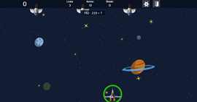

<https://mathsframe.co.uk/en/resources/resource/289/KS2_Maths_Invaders>

May be worth selecting ‘subtraction’ to really warm up for today’s learning!

Main learning: Number and Place Value

Bronze – This is aimed at those who need a bit of a recap on missed learning -

Follow the folders on Microsoft Teams or your class page to find the ‘Tuesday Bronze Questions’ and ‘answers’ files. There is additional reasoning included in Tuesday’s folder and Bronze questions are 1-3.

Silver - This is aimed at an expected year 5 standard -

Follow the folders on Microsoft Teams or your class page to find the ‘Tuesday Silver Questions’ and ‘answers’ files. There is additional reasoning included in Tuesday’s folder and Bronze questions are 4-6.

Gold - This is aimed at an expected year 6 standard -

Follow the folders on Microsoft Teams or your class page to find the ‘Tuesday Gold Questions’ and ‘answers’ files. There is additional reasoning included in Tuesday’s folder and Bronze questions are 7-9.

SPELLING

This week our focus is on HOMOPHONES

Select a set of spelling words from either Bronze, Silver or Gold

Complete the following spelling activity for today using your chosen word list:

Word Families:

* Say and repeat
* Flashcards of words – remember shape and number of letters
* Games
* Spot the mistake
* Make words with single letters / scrabble pieces

*Pupils practise under Tuesday on the sheet.*

ENGLISH

<https://www.coolantarctica.com/Antarctica%20fact%20file/History/The_heroic_age_of_Antarctic_exploration.php>

Read the above to help set the scene of exploration and 1914.

Use the fact sheet about Shackleton (in the link above) to help with the tasks.

Task 1: Create a role on the wall with descriptions of Ernest around the outside (What he may have looked like) and inside (his character and personality).

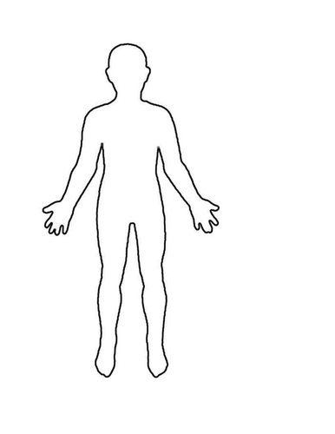

Task 2: Write a description about Shackleton using a range of sentences and exciting vocabulary. (See word mats on class pages and teams for ideas of vocabulary)

Science

Play Guess Who using the actual game or by observing family members present or from photographs at home. This is a good way of introducing the concept of grouping and classifying based on observable features.

* Who was Carl Linnaeus?
* When did he live?
* What is he famous for doing in the scientific area of biology?

Children to complete a quick google search and retrieve some facts about this famous scientist. Children to think of their favourite animal i.e. domestic cat. Complete a quick google search for classification information for their animal and record these facts in their books. (use Wiki as its fast!)

Look at a range of different classification keys, including branching, dichotomous and tabular keys. Practise using the keys to identify an animal or plant. Which key do you find easiest to use? (Keys can be searched for and downloaded easily from google / bing)

Pasta or toy sort activity

Take turns to sort and group a range of dried pasta or toys in different ways. Explain your thinking and categories to a parent. How many different ways can the pasta be sorted? Parents can you give feedback and suggest ways they could improve their key?

Create a classification key for your home bubble:

Classification relies on excellent observation skills. How things are grouped and classified at home. Do you keep cups, pans and food in different cupboards? Are knives, forks and spoons kept together or separated in a drawer? Get the children to think about their bedrooms. What items do they keep in there and how do they group them?

Think creatively – classify your family! (Remember they may have similarities and differences they don’t know about for example Who can roll their tongue? How do people clasp their hands? Does everyone’s hair whorl grow in the same direction?)

**Take photos of children in action creating their classification keys and add these to their books alongside a brief description of the task. Upload your evidence to Teams or**

**READING**

**Skill Focus: Retrieve and record information/identify key details from fiction and non-fiction**

Power point Slides 1 - 9

**Text: Ice Palace read by Miss Flisher**

Ensure children have pen

Use PP to teach retrieval skills. Work through for 15 mins asking the questions posed and discussing. Address the misconceptions you find. Use quick fire questions to engage all with w/bs e.g. write down a verb/noun/fronted adverbials.