**Design and Technology Definitions**

**abrasive**

a material which smoothes and removes marks from wood, plastics and metal; see **glass paper** and **sand paper**

**acetate sheet**

a thin transparent plastic usually colourless but also available in coloured form; a useful material when transparency is needed e.g. in making a torch, or windows in a model of a building

**adhesive**

a substance used to stick materials together; examples include pva glue, cow gum, low temperature hot melt glue

**adult-helper**

an adult other than a teacher who provides support in the classroom. Make sure any adult helpers are aware of health and safety issues and also expected learning outcomes for each activity they help with.

**advertisement**

information about a product or service used to attract potential consumers; advertising takes place in newspapers and magazines, on hoardings, on radio and television and on the Internet

**advertising copy**

the form of words used in an advertisement. Pupils can learn a lot from both studying and creating such copy

**aesthetic considerations**

the area of design concerned with making products look attractive

**allergy**

unusual sensitivity to the action of food, pollens, insect bites etc. You should find out about any allergies your pupils may have to foods or materials before using them in the classroom. You should get parental approval for activities that involve tasting food.

**annotations**

brief notes added to design sketches to make things clearer or to give more detail

**appearance**

the way something looks to an observer

**artefact**

a made object

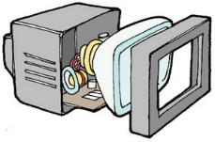

**assembly**

the way parts of a product are fitted together

**assessment**

a judgement of a pupil's achievement

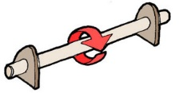

**axle**

the **shaft** on which wheels are carried. The wheels are either fixed so that they turn with the axle or able to spin freely on the axle.

**batch production**

batch production refers to the process of making several to many single items at the same time to give a 'batch' of those items. In school children can carry out batch production in making food products. A baking tray of jam tarts would constitute a batch

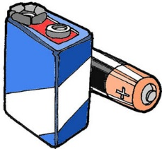

**battery**

a device for pushing an electric current around a circuit. Batteries come in different voltages 1.5V, 3V, 4.5V, 6V and 9V. The bigger the voltage the harder the battery 'pushes' the electricity around the circuit. If the voltage is too large the components will overheat, stop working properly and may be destroyed.

**battery holder**

a device for holding batteries so that they are connected together to give the voltage you need. A battery holder containing four 1.5V batteries would supply 6V. It is important to make sure that the batteries are the right way round.

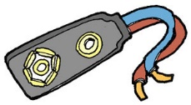

**battery snap**

a connector made from a press stud and wire, used for connecting battery holders and pp3 batteries to light bulbs, motors etc.

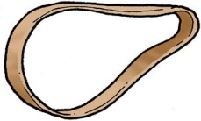

**belt**

- a device used to connect two wheels on different shafts so that as one rotates the other rotates as well. You can use rubber bands as belts.

**bench hook**

a device to make it easy for pupils to saw strips of wood to length

**big task**

a Nuffield design and make activity

**biodegradeable**

able to be broken down by the action of microorganisms

**bracket**

a device used to form a joint between two parts usually at right angles

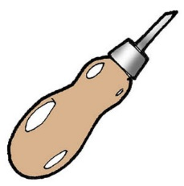

**bradawl**

a sharp tool for making small holes either through thin materials or into soft block materials; should be used under supervision

**brainstorming**

a way for a group of people to think of lots of ideas quickly

**buzzer**

an electrical component that makes a buzzing noise when connected to a battery

**CAD**

computer aided design; the designer uses the computer to help with the production of the design 'on screen' instead of developing the design by drawing on paper or making 3D models



**cam**

a non circular wheel that rotates and moves a **follower**. It converts the rotary movement of the cam into **reciprocating** or **oscillating** movement of the follower. Sometimes a circular wheel mounted off-centre onto a shaft is used as a cam, see **eccentric**

**centre finder**

a device used to mark the centre of a circle

**characteristics of a material**

the physical properties of a particular material; e.g. its **hardness**, **strength** and **stiffness**

**charactistics of material**

the physical properties of a particular material; e.g. its **hardness, strength** and **stiffness**

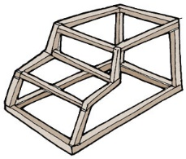

**chassis**

the frame of a vehicle

**chooser chart**

a chart showing information useful in making design decisions. Each chart presents information about a particular area of design and technology in a way that allows users to see which parts might be useful in their design.

**circle cutter**

a useful tool which can cut a circle from paper or card; should be used under supervision

**circuit**

an arrangement of components that provides a continuous pathway through which an electric current can flow

**classroom management**

ways of organising the resources, pupils and helpers in your classroom so that teaching and learning can proceed in an efficient and safe manner.

**client**

a person using the services of a designer. In the primary school the client is likely to be the person who is going to use the final product but in the world outside school the client is often a manufacturer and it is their customers who use the final product



**clockwork motor**

a component that provides rotary movement when it has been wound up. The energy source is an internal spring. Winding up stores energy in the spring. This energy is released slowly to make the shaft of the motor rotate

**collections**

a set of products you can use to illustrate ideas and principles in D&T. A set of simple tools used in the kitchen is a good starting point. There is a tutorial on collections.

**component**

the name given to one of the parts that make up a product

**construction kit**

a set of parts that can be assembled into a variety of working models which can then be taken to pieces e.g. Lego, K'nex, Meccano.

**consumable materials**

materials used to make products e.g. paper, card, wooden strip, plastic sheet, metal rod. These materials get used up and have to be replaced if pupils are to continue designing and making.

**consumer**

anyone who purchases goods or services

**control**

the name given to that part of design and technology concerned with the way mechanical, electrical and electronic devices work; hence control technology.

**cookery aprons**

protective clothing worn by pupils during work with food

**corrugated plastic**

a form of sheet plastic that is light yet strong and stiff; very useful for simple constructional work as it can be easily cut with scissors or a **craft knife**

**craft knife**

a sharp single bladed knife used to cut paper, stiff card and sheet plastic; should only be used by older pupils under close supervision

**criteria for success**

the principles or standards by which a design is judged

**cultural variations**

differences in what people believe, the sorts of things they like and dislike, the products they design and make, the way they behave and dress depending on their culture. For example the patterns of lines in Celtic knot work is distinct in appearance.

https://20353.stem.org.uk/Nuffield%20Glossary2/data/images/originals/cut_away01-15204.jpg

**cutaway view**

a drawing that shows the construction and internal detail of an object by showing the outer parts 'cut away'

**data collection**

the collection of information that is useful in understanding a design brief and developing design ideas. **Questionnaires** are structures used to collect data from potential users.

**decoration**

the application of colour, texture and pattern to a surface to improve its appearance

**design brief**

a summary of the aims of a design and the kind of product that is needed. A closed brief says what the product will be. An open brief leaves it for the designer to decide

**design criteria**

a list describing the standards that a design must meet if it is to be successful

**design decisions**

a product is the result of the design decisions made by the designer about things such as Why (is it needed?); Who (is the outcome meant for?, is to be involved in its production?); What (should the outcome do?, should it be made from?, shape/colour should it be?

**design proposal**

a response to a design brief, a description of the product to be made in sufficient detail that the designer and/or the client can decide whether it is worth developing the proposal further

**design-related research**

research to find information that is useful in understanding a design brief and developing design ideas

**designer**

any person who designs things

**designing and making assignment (DMA)**

an acfivity in which a pupils designs and makes a product; see **big task**

**difference test**

a test to find out if people can tell the difference between slightly different food products

**disassemble**

to look closely at or to take apart carefully so that the parts of a product may be inspected to find out their purpose

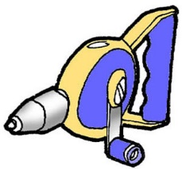

**drill**

a tool used for making small round holes in wood, plastic and metal

**drill bit**

the cutting tool used in a drill. It is held in the chuck and cuts into the material as it rotates

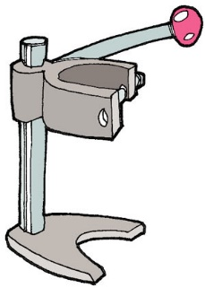

**drill stand**

a device for holding a drill so that it is easy to use and it drills perpendicularly

**eccentric**

a circular wheel with an off-centre **axle**



**electric motor**

a component that provides rotary movement when connected to a battery

**electrical component**

a part of a product that is used in an electrical circuit e.g. a bulb, a motor, a buzzer

**electrical switch**

a component that controls the flow of electricity by either turning it on or off or by changing the path along which it flows

**environment**

the surroundings, e.g. a room, a town, a park, a forest

**environmental concern**

worries about these effect of industrial and commercial activity on the natural world and on the people, animals and plants that live in the world

**ergonomics**

the study of how easy it is for people to use their working environment

**evaluate**

assess how well a product or service meets the design criteria or specification

**fabric**

a thin, flexible sheet material usually made from woven or knitted textiles

**felt**

a textile fabric made by compressing woollen **fibres** into a single sheet

**fibre**

a fine thread; most textile fabrics are composed of fibres that have been spun into thicker threads which are then woven or knitted

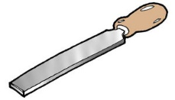

**file**

a tool for removing burs from freshly sawn metal

**finishing techniques**

methods used to make the surface of wood, metal and plastic smooth; these usually involve the use of **abrasive** papers

**fitness for purpose**

a criteria used in evaluating a product; the evaluator asks how well the product performs the function for which it was designed. If the product performs well then the product is said to have fitness for purpose

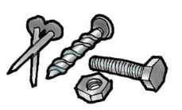

**fixings**

things used to fix materials together, e.g. nails, screws, nuts and bolts

**flavour**

the sensations detected by the tongue which, with smell and texture, give food its taste

**flow chart**

a way of planning how to carry out a task by drawing a sequence of boxes joined by arrows. Each box contains a short statement about one stage

**foam materials**

solid materials that include lots of air bubbles - Aero chocolate is an everyday example. Plastic foams are useful in design and technology. Expanded polystyrene is foam that comes as rigid lightweight sheets, blocks or 'bobbles'. It is used for packaging.

**focused practical tasks**

short practical activities that teach a specific piece of knowledge, understanding or skill; see **small tasks**



**follower**

usually a **slider** or **lever** that is moved by a **cam** or an **eccentric**

**font**

a particular style or design of lettering

**food hygiene**

the standards of cleanliness necessary when dealing with food as a material for design and technology. There is a tutorial on food hygiene

**food sensitivity**

some children are particularly sensitive to certain foods and may have an allergy. You should get parental approval for activities which involve tasting food.

**found materials**

materials available from discarded objects; often packaging e.g. washing up bottles, shampoo bottles, cereal packets; sometiimes referred to as **junk materials** or **reclaimed materials**

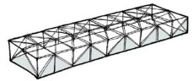

**framework**

a structure assembled from long thin parts as in a pylon or girder bridge. Your pupils can make frameworks from drinking straws

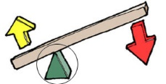

**fulcrum (pivot)**

the point of support of a lever, around which it moves

**function**

the purpose of a product or part of a product as in the function of a whisk is to mix the eggs with the milk and the function of the handle in the whisk is to make the gear go round to drive the blades

**functional decoration**

a decoration that also has a practical purpose e.g. wrapping a handle with string not only makes the handle look more attractive it also improves the grip

**g-clamp**

a device you can use to clamp bench hooks to tables for added stability and/or to hold work steady or to keep parts assembled while glue dries

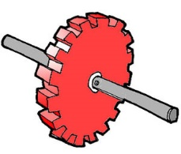

**gear**

a toothed wheel,usually fixed to a shaft so that it rotates at the same speed as the shaft

https://20353.stem.org.uk/Nuffield%20Glossary2/data/images/originals/gear_train02-15311.gif

**gear train**

gear wheels with teeth meshed together so that one drives the other



**gearing down**

using a gear train to increase output force and reduce speed



**gearing up**

using a gear train to decrease output force and increase speed

**glass paper**

an **abrasive** paper used to smooth the rough edges of freshly sawn wood

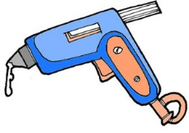

**glue gun**

a device for applying hot melt glue to parts to be joined together. A low temperature version is available for use in primary schools and should only be used by older pupils under close supervision

**graphics**

writing, drawing, printing, decorating etc. on a flat surface

**group work**

lots of Nuffield tasks can be done in groups - look for the special group icon

### hardness

that property of a material concerned with how difficult it is to scratch. A hard material is difficult to scratch; a soft material is easy to scratch

### health and safety

the activities carried out in your classroom must meet health and safety requirements. You can ensure that this is the case by carrying out **risk assessments** and organising the activities so that all risks are controlled.

### hole punch

a device for making small circular holes in paper and thin card. Some produce two holes so that paper or card can then be kept in ring binders. Others produce a single hole. See also paper **drill**

### hydraulic

operated by liquid under pressure

### hygiene

the principles of maintaining health through cleanliness

### hygienic

working in a clean and therefore healthy way. See also **food hygiene**

### identifying needs

the process of looking at the behaviour and conditions of people and other living things and identifying what they need to be healthy, comfortable, interested, at ease etc.

### image board

a collection of pictures, cut-outs from magazines or newspapers, quick sketches, especially taken photographs, to do with people. Pictures of the people themselves, where they live, where they work or go to school, what they do in their leisure time, all contribute to an image board

### implementing improvements

the process of making things better than they are at the moment, usually in response to an **evaluation** of a **product** or **situation** in which shortcomings have been identified

### individual work

some Nuffield tasks should be done individually - look for the special individual work icon

### information sources

places to look for information that will be useful in helping to understand a design brief and develop design ideas e.g. books, magazines, radio and television programmes. the internet. Pupils can also use people as information sources

### insulation

a material that is used to prevent heat transfer. It will keep cold things cold and hot things hot. Or a material that does not conduct an electric current and is used to cover wires that are carrying an electric current

### investigate

to find out by personal enquiry and experiment. Many small tasks in Nuffield D&T are investigations

**Jinks' corner**

the name given to triangular pieces of card that are used to join two pieces of wooden strip at right angles to one another

**jigs**

a jig is a device that allows a piece of wood, metal or plastic to be held and cut accurately to give a piece of a particular size without the need for measuring or marking out. In the case of wooden strip, like that used to make simple frames, precise positioning of a block of wood to act as a &lsquo;stop&rsquo; together with a fixed position sawing board allows strips of wood of identical length to be cut from longer lengths without measuring. If your class needs lots of several different pieces cut to an accurate length then you can set up a production line based around using such a jig.

**joint**

a means of connecting two pieces of material, Some joints are permanent e.g. joints that are held together with an adhesive. Other joints are temporary e.g. joints held together by velcro

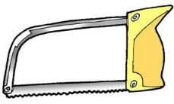

**junior hacksaw**

a hand held device for cutting wood, plastic and metal strips to length

### junk material

see **found material**

### kit

a set of materials, parts or components that can be used to teach concepts and principles in design and technology

**LED (light emitting diode)**

an electrical component that lights up when a current passes through it but, unlike a light bulb, it does not become hot

**learning possibilities**

a list of the learning that takes place during a Nuffield **big task** and the associated **small tasks**

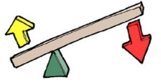

**lever**

a bar or rod that moves about a **pivot** or **fulcrum**

**linear movement**

movement in a straight line

**loom**

a device for producing **fabric** from threads by **weaving**

**manufacturing**

this is the word used to describe the way that products are made in the world outside school. It usually implies making in quantity. For example confectionery such as Kitkats are manufactured at a rate of many thousands per hour.

**market research**

the process of finding out which products and services people want and what they are likely to spend to get them

**marketing**

the process of making customers aware of products and services, attracting new customers to a product or service, keeping existing customers interested in a product or service, building and maintaining a customer base for a product or service. **Advertisements** play a large part in marketing

**mass production**

mass production refers to the process of manufacturing in the world outside school where products are made in there thousands. This requires the use of machines as well as people. Increasingly people are being replaced by machines that are computer controlled and can work 24 hours per day without rest.

**materials**

the matter from which things are made e.g. wood, metal, plastic, fabric, food

**mechanical component**

a part of a product that is used in a mechanism e.g. a **wheel**, a **gear**, a **pulley**

**mechanism**

a set of mechanical components assembled together to perform a particular task e.g. a gear train to increase the speed of rotating parts as in a rotary whisk

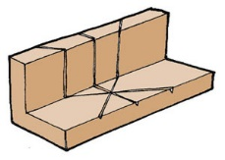

**mitre block**

a device to allow a saw cut to be made at 45Â° so that two parts can be joined to form a right angle (90Â°)

**modelling design ideas**

the process of representing ideas from `inside the head' in a form that can be shared with oneself and others. The form of the model can be either 2D e.g. a sketch or diagram perhaps with notes, or 3D e.g. a construction from paper, card, straws, pipe cleaners.

**mood board**

a collection of colours and shapes of paper, card and fabric that evoke an emotional response. Designers and pupils can use image boards to decide on the right colours and convince others of their choice

**motor**

a device that provides rotary movement, see **electric motor** and **clockwork motor**

**mould**

a hollow shape into which a liquid is poured and left to set solid to produce a product in the shape of the mould e.g. a jelly mould or a plaster of Paris mould

**mouldable materials**

materials that are easily shaped into different forms e.g. plasticine, play dough and most food materials

### net

a 2D shape that can be folded to give a 3D form, sometimes called a development

**on/off switch**

a switch that stays in the position set, either on or off

**one-off production**

this is the way children usually make things in school. They make a single item of their design idea, sometimes referred to as a one off. In the world outside school one offs are often very expensive to buy as a lot of time and effort goes into producing the item.

**opaque**

an opaque material is one that you cannot see through



**oscillating movement**

swinging to and fro like a pendulum

**packaging**

the wrapping around products that is used to protect the product from damage, to keep the product clean, to extend shelf life, to promote the product and to provide information about the product

**paper drill**

a device for making small round holes in paper, card or corrugated plastic where the office punch and single hole punch do not reach

https://20353.stem.org.uk/Nuffield%20Glossary2/data/images/originals/paper_fastener02-15417.jpg

**paper fastener**

a component useful for providing a temporary join between two parts. It links the parts by sticking through a hole in each part. The head prevents the fastener from coming out in one direction; the legs can be opened out to prevent the fastener from coming undone.

**permanent joining**

a joining process in which the joining is permanent and not easily reversed e.g. glueing

**perspective drawing**

a drawing that shows depth as well as length and height

**plaiting**

twisting together fibres to make them stronger and/or more attractive

**pneumatic**

driven by compressed air

**product**

any manufactured item

**product image**

the characteristics of a product as perceived by the public e.g. hi tech, low tech, eco friendly, traditional, modern, sophisticated, naive

**products and applications**

a section in the knowledge and understanding part of the programme of study for Design & Technology as given in the National Curriculum Orders. It states that pupils should be taught to investigate, disassemble and evaluate simple products and applications and to relate the way things work to their intended purpose, how materials and components have been used, people's needs and what users say about them. There is a set of Nuffield activities based on investigation, disassembly and evaluation of common products and applications e.g. carrier bags.

**programme of study grid**

a chart that relates the scope of a particular Nuffield activity to the programme of study for Design & Technology as given in the National Curriculum Orders

**progress**

the gains in learning made by a child over time. It is important that a child makes progress in each of three domains in design and technology - designing, making and knowledge and understanding

**protoype model**

a model of a design that shows how it works, what it looks like and can be used so that it can be fully evaluated. Most prototype models are one-offs so they do not fully reflect the manufactured design. Most products produced by children are prototype models.

**pulley**

a **wheel** used with a **belt** that grips onto it. There may be a groove in the pulley to help the belt grip

**punch**

see **hole punch**

**push fit**

a tight fit that will not allow two parts so fitted together to move independently. You can use a push fit to join a **wheel** to an **axle** so that as the wheel turns the axle turns too. In this case the axle will fit tightly in the hole in the wheel.

### quality

the degree of excellence in a product or service. It is important that children are taught to understand the difference between quality of design and quality of manufacture (or making).

### questionnaire

a device consisting of a series of questions designed to elicit the views and opinions of those answering the questions. Some questionnaires are administered by a person who asks the questions and record the answers but many are filled in unaided by those answering the questions using mainly tick boxes. Pupils can design their own questionnaires, and if the number of responses is very large, they should be processed by computer. There are several suitable programs designed for school use.

### reciprocating movement

movement backwards and forwards in a straight line

### reclaimed material

see **found materials**

### recording observations

making a permanent record of what is happening in a particular situation. You can use any of the following: sketches and notes, photographs and notes, audio recording and video recording.

### recording results

making a permanent record of measurements and observations from an investigation. Results are often most usefully recorded in table form.

### reinforcing

strengthening or stiffening a part in a product so that it can perform its function better i.e. is less likely to break or bend

### reliability

the quality of sound and consistent performance or behaviour

### religious differences

differences between people in religious belief, religious behaviour and religious customs

### resource requirements

the stimulus materials, consummable materials and components, tools and equipment likely to be needed in a design and technology lesson

### risk assessment

the process by which you consider the seriousness of any risks in a learning activity and then devise ways to reduce the hazard e.g. clear instruction and close supervision

**sand paper**

the common (but strictly incorrect) term for an **abrasive** paper used to smooth the rough edges of freshly sawn wood

**sanding block**

a piece of cork or wood or plastic wrapped round with sandpaper. It is often easier for young children to work with a sanding block than with a piece of sandpaper when they are smoothing a flat surface

**scissors**

a hand tool that is used to cut paper, thin card and fabric

**sensor**

a **component** that can detect changes in its surroundings e.g. a light sensor can detect changes in brightness, a heat sensor can detect changes in temperature. Sensors are often connected to computers in order to capture data about a particular environment.

**shaft**

see **axle**

**sheet material**

material in a form where the length and width are much greater than the thickness e.g. paper, card, **fabric**, **corrugated plastic**

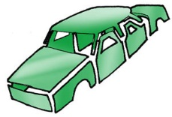

**shell structure**

a structure composed of **sheet material** that encloses a space

**situation**

a place, with its surroundings e.g. a house in a fine situation or a set of circumstances e.g. a difficult situation

**sliding fit**

a fit that will allow two parts so fitted together to move independently. You can use a sliding fit to join a **wheel** to an **axle** so that as the wheel turns the axle does not. In this case you will have to find a way to prevent the wheel from sliding completely off the axle.

**small task**

a focused practical task in a Nuffield activity developing knowledge and skills which will be needed for the subsequent **big task**

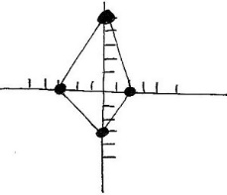

**star chart**

a visual representation of the attributes of a food product. It consists of several axes each representing a particular attribute that can be given a score. Joining the score points often creates a shape like a star, hence the name.

**stiffness**

that property of a material concerned with how difficult it is to bend. A stiff material is difficult to stretch or bend

**stimulus materials**

anything which helps to set the context for a task - includes stories, collections, broadcast materials etc.

**strength**

that property of a material concerned with how difficult it is to break. A strong material requires a large force to break it.

**structure**

an assembly of parts that supports a load and/or encloses a space. See **framework** and **shell structure**.

**supervision**

the use of some tools or processes should always be supervised by an adult.

**survey**

a broad investigation into a **situation** or **environment**. It can involve definite measurements as in a survey of the school grounds or elicit opinions in a survey to find out who thinks solar power is a good thing. Surveys of opinion rely on information from questionnaires.

**target audience**

a particular group for whom a product or service has been designed; often used in the media industries to describe the group of listeners or viewers

**tasting tests**

investigations in which pupils taste food in order to evaluate it. Such tests might be concerned with comparing different foods to find out which the taster likes best, to put the foods into an order according to a taste e.g. sweetness, or to find out if the taster can tell the difference between the foods.

**teamwork**

working as part of a group in which there is a shared goal and to achieve this different members of the team take on different roles

**technical advice**

there is a technicla advice section in most Nuffield activities - see also related tutorials on this site

**template**

a template is a device that allows a shape to be drawn accurately and repeatedly onto a sheet of materials e.g. paper, card, fabric. It can be a thin sheet of plastic in the shape of the shape to be transferred, in which case a pencil is held against the *outside* edge and follows the edge around the shape thus drawing the shape on the sheet of material beneath. Or it can be a thin sheet of plastic in which there is a hole in the shape of the shape to be transferred. In this case the pencil is held against the *inside* edge and follows the edge around the shape thus drawing the shape on the sheet of material beneath. Children find it easier to use the &lsquo;hole&rsquo; template.

**temporary joining**

a joining process in which the joining is temporary and easily reversed e.g. laces

**testing**

investigating a product or material to find out how it performs in use

**textiles**

any materials in the form of a cloth. These may be woven in which one set of threads passes over and under another set of threads at right angles to it to form the fabric, or knitted in which a single thread forms rows of loops which interlock to form the fabric.

**texture**

the feel of food in the mouth e.g. creamy, chewy or the feel of a surface e.g. hairy, bumpy

**tiny task**

a short task in a Nuffield activity, usually investigative, disassembly or evaluative

**title**

text

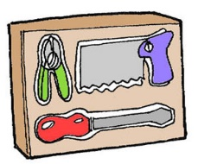

**toolboard**

a device to display tools so that they are easily visible, easily accessed and easily checked

**tools**

devices to cut, shape, form and mix materials

**translucent**

a translucent material is one that transmits light but you cannot see through it

**transparent**

a transparent material is one that you can see through

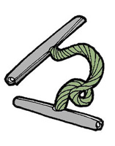

**treasury tag**

- a device to join papers together. It consists of a short lace and two metal or plastic tags. The lace passes through a hole in the sheets of paper and keeps the papers together because the tags prevent the lace from coming out.

**typical outcomes**

these are illustrated examples of the sort of product pupils will design and make when they tackle a Nuffield activity

### user needs

people who use goods and services do so because those good and services meet their needs e.g. a food product meets the need of hunger, a pair of gloves meets the need of keeping warm

### user preferences

people who use goods and services show preferences towards particular goods and services that appeal to them in some way e.g. a woolly hat that is bright red with yellow bobbles might appeal to a child but is unlikely to appeal to an adult

### user reaction

people who use goods and services react towards them in particular ways. In some cases the reaction is negative, in other cases positive. The intensity of the reaction can also vary.

### user wants

people may want particular products in order to meet a need e.g. if a person is thirsty they need a drink but they might say, "I want a Coke."

**values**

the principles and standards used in judging the worth of something

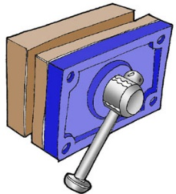

**vice**

a device for holding materials or parts so that they are easy to work on

**vocabulary**

the range of words used by someone. In the case of design and technology your pupils will need to be taught a rich variety of new words, which describe the concepts, materials, components, tools, products and processes.

**wheel**

a circular disc, which may be fixed to a **shaft** so that it rotates at the same speed as the shaft, or fitted onto a shaft so that it can spin while the shaft, remains stationary. The surface of a wheel where it touches the ground can be covered with materials to improve grip.

**whole class session**

a teaching session in which the teacher addresses the whole class. These should always include an interactive element to draw in all pupils. Most Nuffield activities suggest question sets to help you involve pupils and tease out responses useful in achieving the aims of the lesson - look for the special whole class icon.

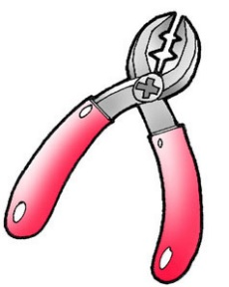

**wire stripper**

a tool for removing the insulation on electrical wiring

**working drawing**

plans which show how a product may be made

### yarn

a spun thread used for weaving and knitting