

Reading extract and questions:
Year 3-4
Funfair
Set A/B

For two whole days, Rish had watched the activity at the park with fascination as he walked to and from school. First, he had noticed the lorries and vans arriving with their brightly coloured trailers. Then he had seen the people slowly piecing together all the rides and attractions. Finally, it was ready to open.
In the morning, Rish’s dad had promised to take him and his sister, Padma, to the funfair that evening after school, as long as they had finished their homework and weather permitting.
The moment he had put his pencil down, Rish was dancing around the house, wanting to set off.
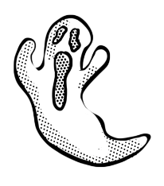
“Calm down, young man,” said his mum, “your father isn’t even home from work yet.” When, at last, Rish heard the key in the front door, he still had the agony of having to watch his dad have a quick snack before they could set off.
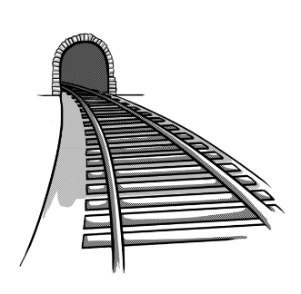
“I’m the bravest,” said Rish as they paid their entrance fee. “I’m going to go on all the biggest, fastest and scariest rides.” Padma looked up at the big wheel with wide eyes. When she heard the shrieks and screams of the people, she held her father’s hand a little tighter.
To ease her in gently, Dad went with her on a very tame merry-go-round. As he was old enough, Rish was allowed to go off on his own for a bit, as long as they met back at the ice cream stall.
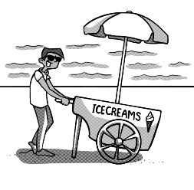
He was quite relieved that no one he knew was there to see him emerge from the ghost train. By the time he had staggered off the waltzer, having been tossed around like a sock in a washing machine, he was feeling rather wobbly. He could see that the big wheel was very popular but he was not certain he could cope with such a height. Telling himself that the queue was too long anyway, he decided to look for his dad and sister.
The minutes dragged by as he lingered around the ice cream stall. Where were they? Had they forgotten him? Was he imagining it, or were some people eyeing him in a funny way. He was beginning to feel uncomfortable. Eventually, he slumped on the floor and buried his head in his hands, partly to avoid the stares.
“Rish? Rish? Are you all right?” said dad, running up to him. “I’m sorry, I didn’t know there were two ice cream stalls.”
“When you didn’t turn up, I suggested that we should go on the big wheel to see if we could spot you from up there,” said Padma. “It was amazing! But then we saw you down here. Can we have another go, Dad, Please!”
“Maybe next time, Pad,” smiled Dad has he hugged his shaking son. “I think Rish has been brave enough for one day.”
Questions for Funfair
Set A

Vocabulary:

1. Look at the first paragraph. Find and copy a word that means great interest.

_________________________________________________________________

2. … brightly coloured trailers … what are trailers in this sentence? Tick one.

wheeled carriers posters

advertisements fairground rides

_________________________________________________________________

3. Look at the paragraph beginning The minutes dragged by … Find and copy a word that means waited.

_________________________________________________________________

Retrieval
4. For how long had Rish been watching the activity at the park?

_________________________________________________________________

5. What did the children have to do before they could go to the funfair?

_________________________________________________________________

6. Where did Dad say they should meet?

_________________________________________________________________

Inference
7. Why was Rish dancing around the house?

_________________________________________________________________

8. Why was it agony to watch his dad having a quick snack?

_________________________________________________________________

9. Why do you think Rish was relieved that no one he knew was there to see him emerge from the ghost train?

_________________________________________________________________

Summarise
10. Here are some summaries of different paragraphs in the text. Number them from 1 to 4 to show the order in which they appear.

Rish goes off on his own.
Rish waits by the ice cream stall.
The funfair gets built.
Rish has to wait for his father to get ready.

Predict
11. What might Rish do if he goes to the funfair again?

_________________________________________________________________

Compare
12. How does Rish’s mood change throughout the story?

_________________________________________________________________________________

_________________________________________________________________________________

_________________________________________________________________________________

Answers for Funfair
Set A:

Vocabulary:
1. fascination
2. wheeled carriers
3. lingered
Retrieval:
4. two (whole) days
5. finish their homework
6. by the ice cream stall
Inference:
7. He was very excited about going to the funfair/couldn’t wait to go to the funfair.
8. It meant he had to wait even longer (before going to the funfair).
9. He didn’t want people to notice that he had found it scary.
Summarise:
10.

3 Rish goes off on his own.
4 Rish waits by the ice cream stall.
1 The funfair gets built.
2 Rish has to wait for his father to get ready.

Predict:
11. Accept reference to any of the following:
- Make sure he knows exactly where he is meeting Dad
- Stay with Dad/go on rides with Dad so he doesn’t feel scared/get separated from Dad
- Go on less scary rides
- Avoid the waltzers/ghost train
- Try the big wheel with his dad and his sister
Compare:
12. At the beginning he is very excited and wants to show how brave he is. At the end he feels scared and worried about the people around him (accept any reference to the change in his feelings about the rides from the beginning to the end).

Commissioned by The PiXL Club Ltd. July 2019
This resource is strictly for the use of member schools for as long as they remain members of The PiXL Club. It may not be copied, sold nor transferred to a third party or used by the school after membership ceases. Until such time it may be freely used within the member school.
All opinions and contributions are those of the authors. The contents of this resource are not connected with nor endorsed by any other company, organisation or institution.
PiXL Club Ltd endeavour to trace and contact copyright owners. If there are any inadvertent omissions or errors in the acknowledgements or usage, this is unintended and PiXL will remedy these on written notification.

© Copyright The PiXL Club Limited, 2019

