Design a sustainable garden/farm
Objective: To design and build a model structure that will enable farmers to grow crops, even in an area that may be flooded.
The big questions:  - What does sustainable mean?  - Why is flooding becoming a bigger issue for farmers?  - What problems will people have if farmers’ crops get flooded?  - Can you find examples of places in the world that flood?  - Will your structure be easy to build for farmers? | Things to think about  What materials will work?  How will I make sure my structure is stable?  Should I go for a big, impressive structure or a smaller, safer one?  How will I make the top of my model suitable to grow crops on? Does it need to be flat? Layered?
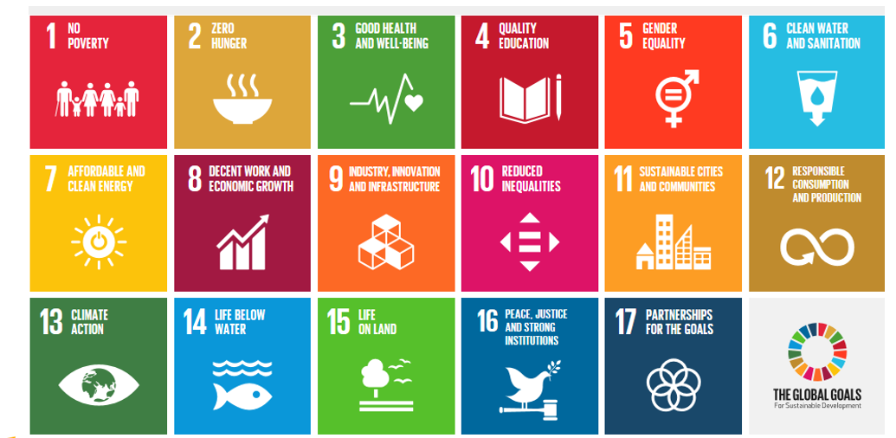
The 17 global goals for sustainable development

Materials  - Junk modelling materials and glue/tape  - A container of water (a sink, large tub, or bowl, even a paddling pool)  - Optional – some compost/soil and seeds. Why not try to grow some crops on your floating garden? Cress is just one idea (you could use damp cotton wool or damp paper towels). | Additional research  - Bangladesh is a country that is in danger of flooding. Do some research on Bangladesh and what organisations are doing to try to help farmers and people grow crops in the face of flooding.
Experiment steps  - Have a think about what materials you will need for a floating garden/farm. Draw and design what you’d like your structure to look like.  - Once you’ve designed your structure, build it! Don’t worry if it takes time for the glue to stick if you’ve used glue – this experiment can be done over the whole week. Decorate them if you’d like to.  - Make a prediction/hypothesis. Will your structure float; will your seeds grow?  - Place your structure into the container of water. Add water to your container – does your structure keep floating?  - Write up your experiment each day. Was your hypothesis accurate? Did your seeds grow? Include pictures and drawings of your experiment.  - How might you improve this experiment?  - Try the extension! | What is the most important variable for this experiment (what is the most important thing for carrying the most passengers)? Is it size, shape or material? Is it a combination of these?  Ideas and learning extensions  - Why not take pictures or film your experiment?  - Make notes of what you find out  - Jot down your findings in a table or a diary  Questions  - Does the material of the structure make a difference?  - Does the length, height or weight of the structure make a difference?  - How long did your structure last in the water?

Extension task
Many parts of the world are in danger of flooding, but many are in danger of drought. Could you design a way of keeping your farming/garden structure watered even during a drought? Experiment, research ideas and record them. Draw your ideas on paper and maybe even build them! Send me your ideas and I will upload them to the website. Good luck and have fun!

