**Knowledge Organiser – Animals including Humans (Science Year 3/4)**

There are four main food types:

|  |  |
| --- | --- |
| **Key Vocabulary** | **Definition** |
| Balanced diet | A diet that means you get the right types and amounts of foods and drinks to keep you healthy. |
| Skeleton | The hard structure that supports the body of a living thing. |
| Muscles | Move different parts of the body, inside and out. |
| Skull | Protects the brain. |
| Spine | Made of vertebrae and support the upper body’s weight. |
| Joints | Hold two bones together and allow movement. |
| Bones | Support and protect organs of the body. |
| Tendons | Attach muscle to bone. |

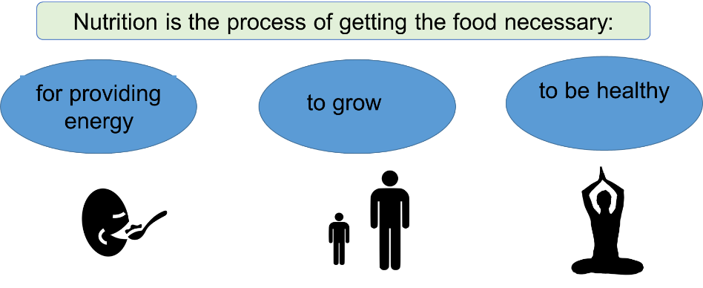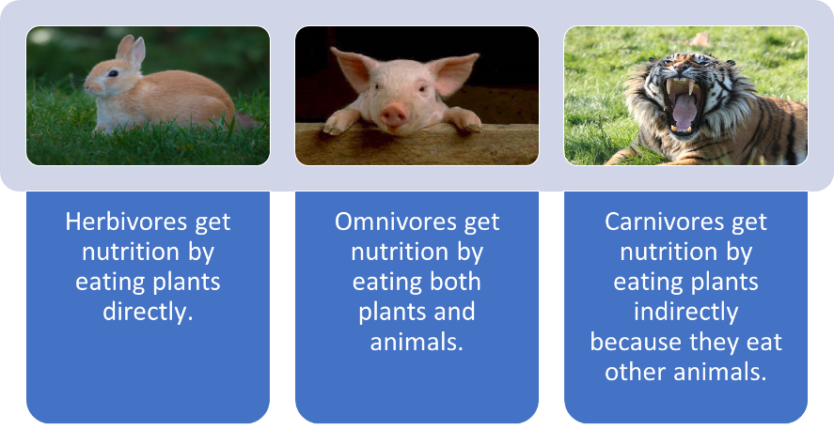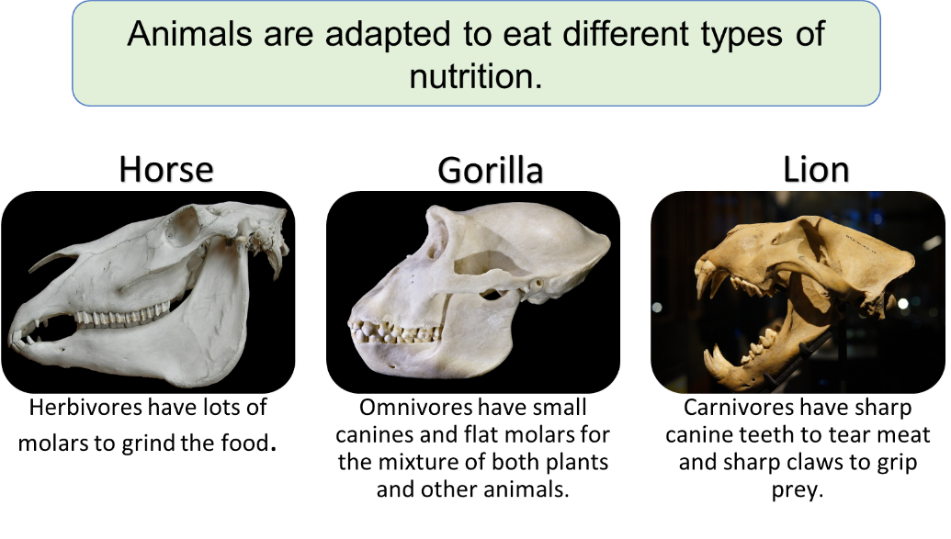

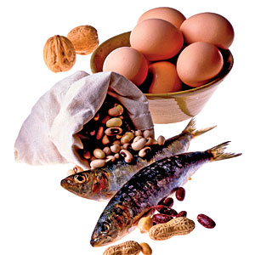

Protein

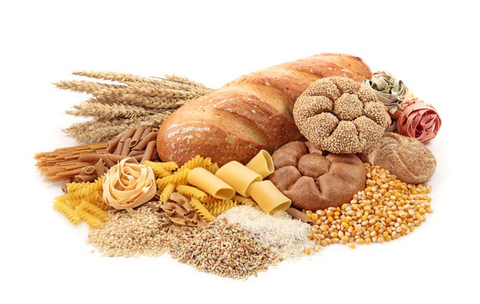

Carbohydrate

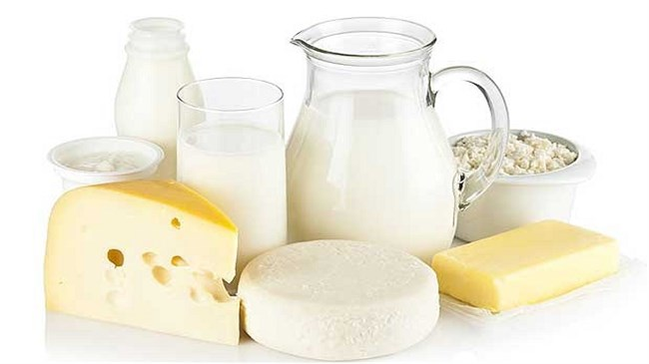

Fat

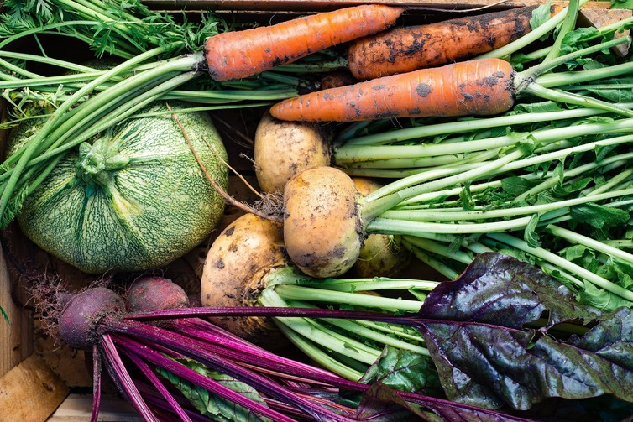

Vitamins and minerals

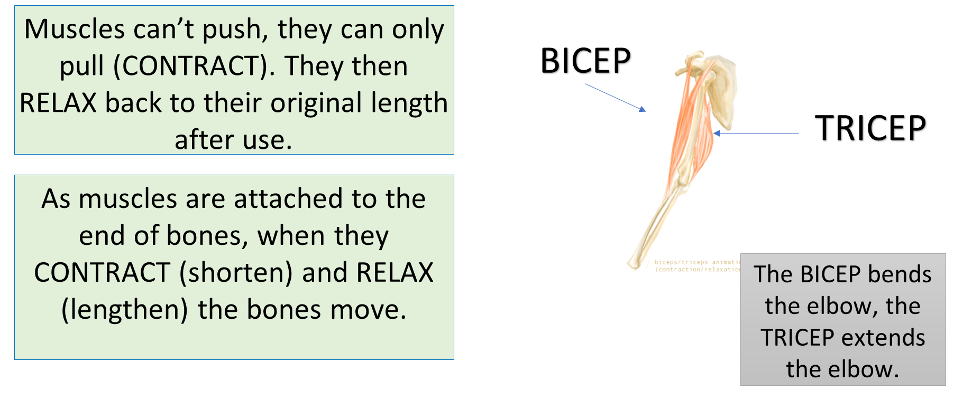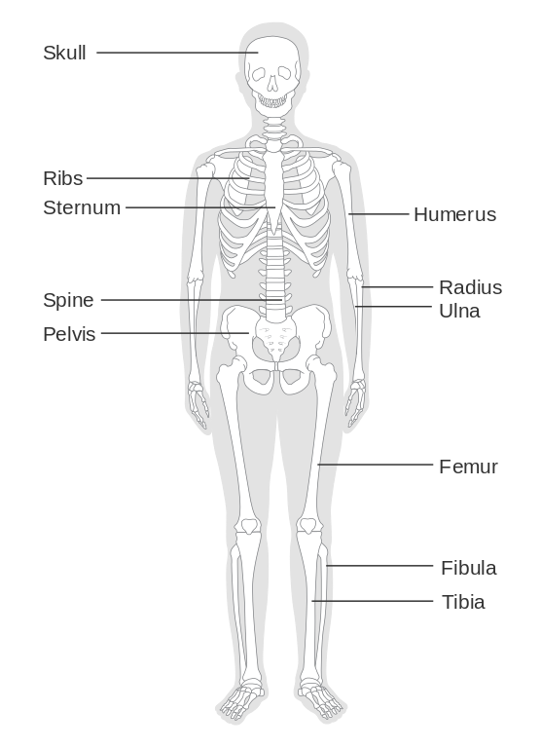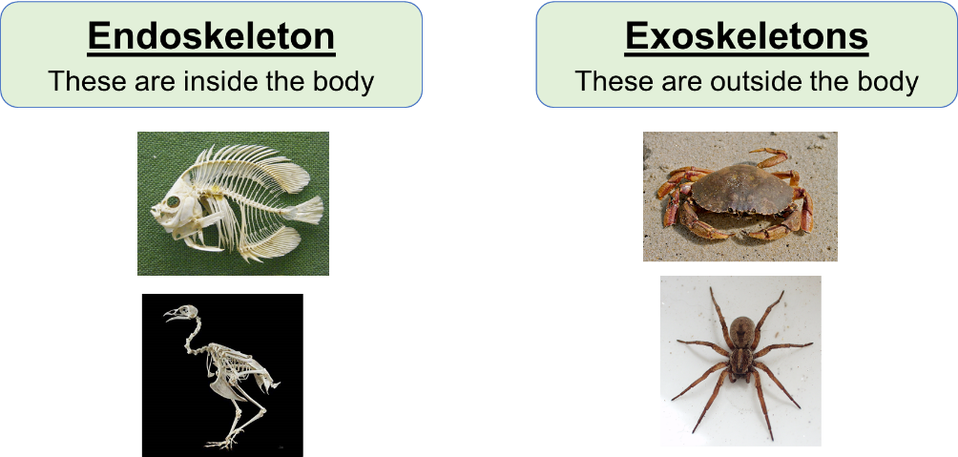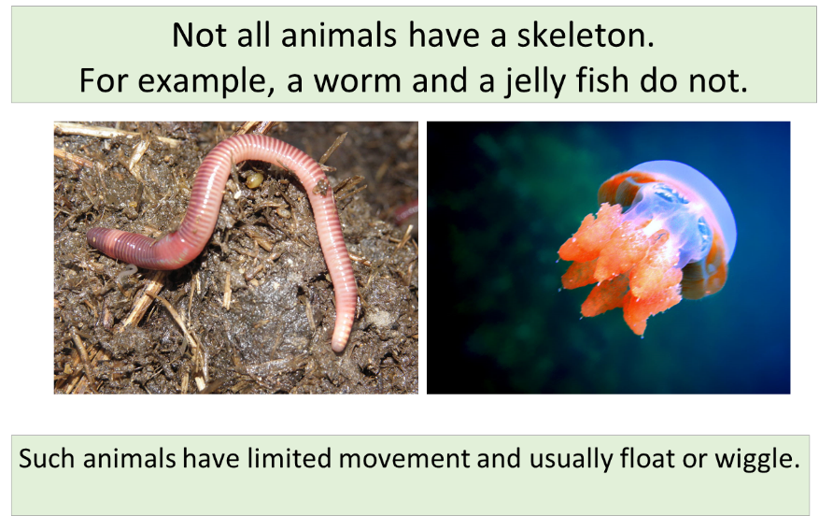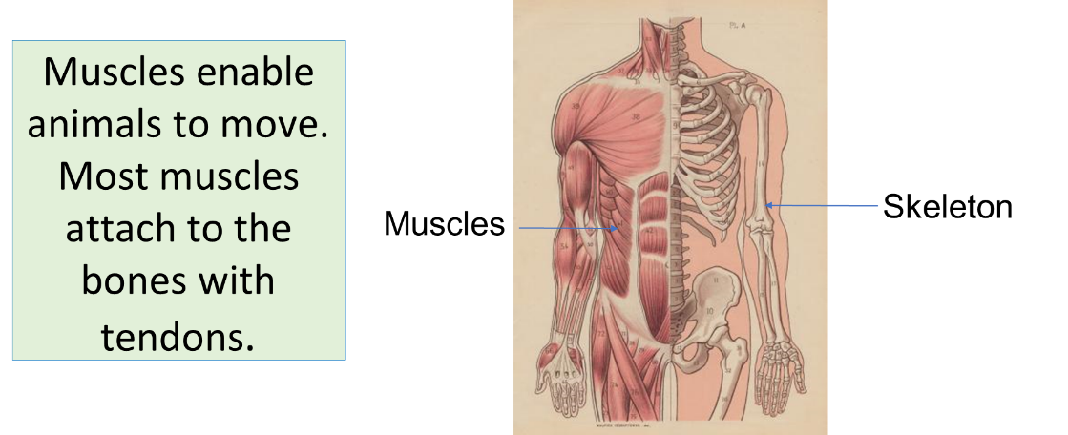

The BICEP bends the elbow. The TRICEP extends the elbow.

TRICEP

BICEP

A skeleton is a framework for the body, made up of bones.

It supports body movements.

It supports the body.

It protects organs and soft areas of the body.

It provides shape to the body.

Vitamins and minerals