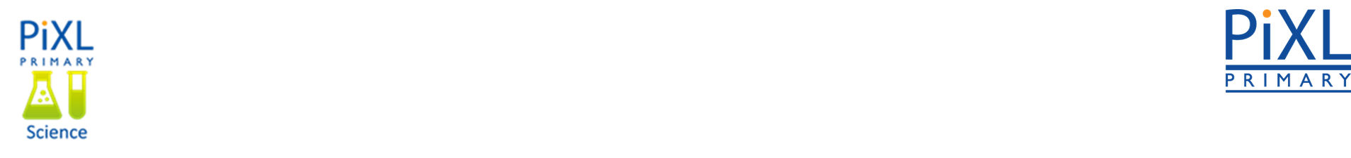**Knowledge Organiser – Light (Science Year 3 and 4)**

|  |  |
| --- | --- |
| **Key Vocabulary** | **Definition** |
| Light | Something that makes things visible. |
| Light source | An object that emits light. |
| Transparent | Used to describe materials that let light through so that you can see things behind it. |
| Reflective | Used to describe materials that reflect light. |
| Opaque | Used to describe materials that you can’t see through. |

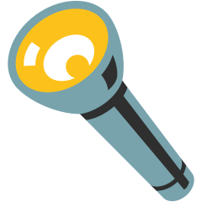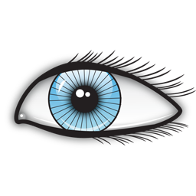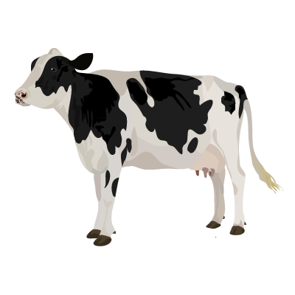

How do we see?

We can see objects because when light hits an object it is reflected (bounces off) and enters our eyes.

Why are the shadows different?

It depends on the amount of light that can travel through each material.

Light is a form of energy.

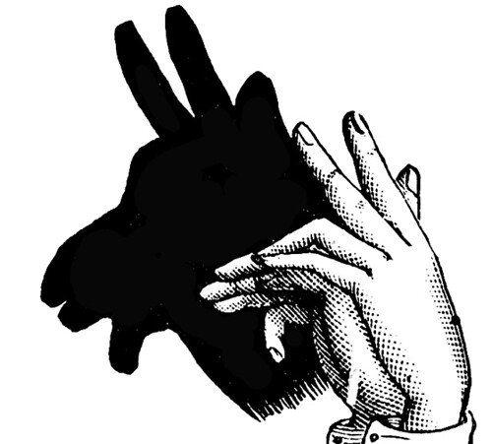

Light usually comes from hot objects, but not always.

Reflective and opaque objects block light and will form a darker shadow.

Translucent and transparent objects let light through and will form either no shadow, or lighter shadows.

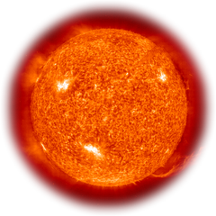

The sun is a natural form of light.

The energy from the sun powers all life on Earth.

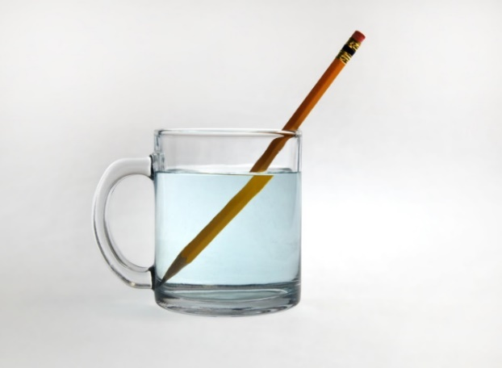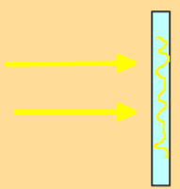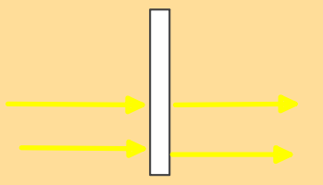 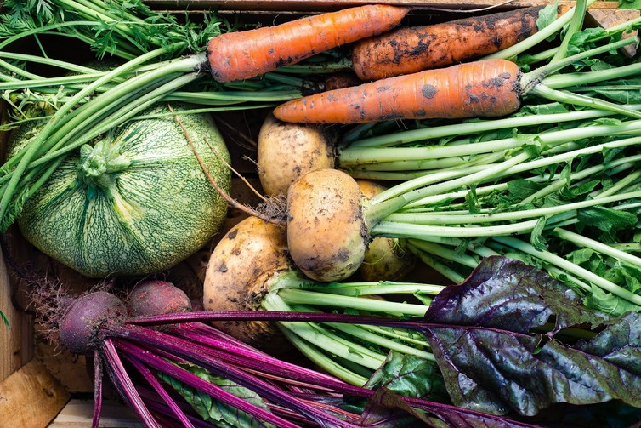

We can use suntan lotion and sunglasses to protect ourselves against the dangerous rays.

Sunlight contains ultraviolet rays. Small amounts of UV light are good for us, but large amounts are bad for our eyes and can cause skin cancer.

When light travels through transparent materials, the light rays bend. This is called refraction.

Refraction

Refraction occurs because light travels at a different speed through the water. This makes the pencil appear bent as it enters the water.

Light reflects off a mirror like a ball hitting a hard surface.

Reflection

Transparent objects let most of the light through.

Translucent objects let some light through.

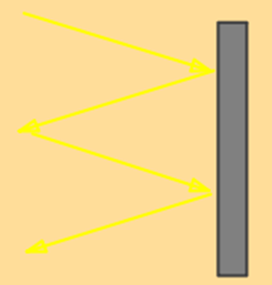

Shiny and light objects reflect light.

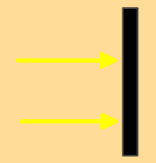

Opaque objects absorb light.

Vitamins and minerals