|  |  |
| --- | --- |
| **Key Vocabulary** | **Definition** |
| Classification | Ways of naming and grouping living things by their similarities and differences. |
| Vertebrate | An animal with a backbone. |
| Invertebrate | An animal without a backbone. |

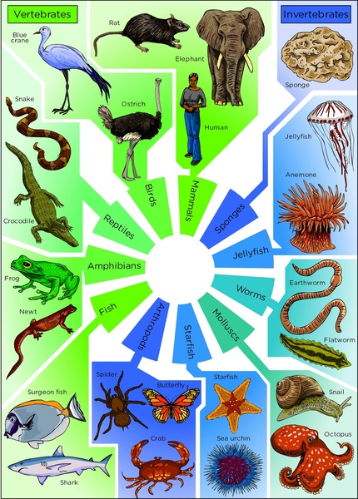** Knowledge Organiser – Living Things (Science Year 3 and 4)**



Larger crystals that interlock.

Marble

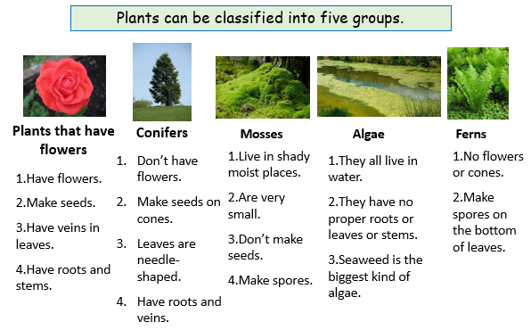

Classification keys allow you to ask a series of questions about a living organism to help you identify it.

**Vertebrates** are animals with a backbone.

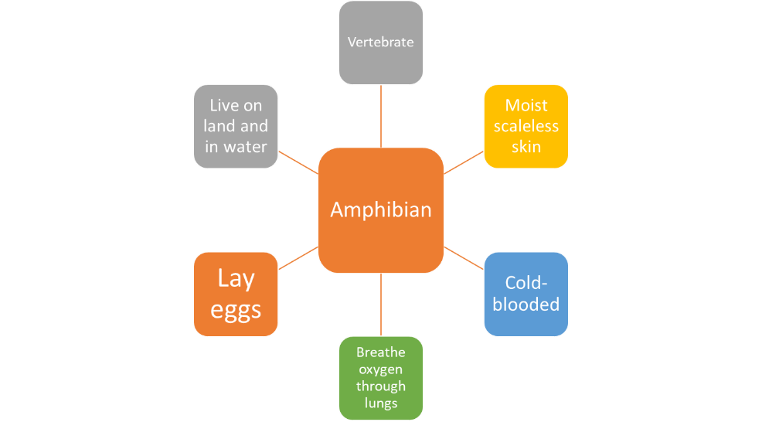

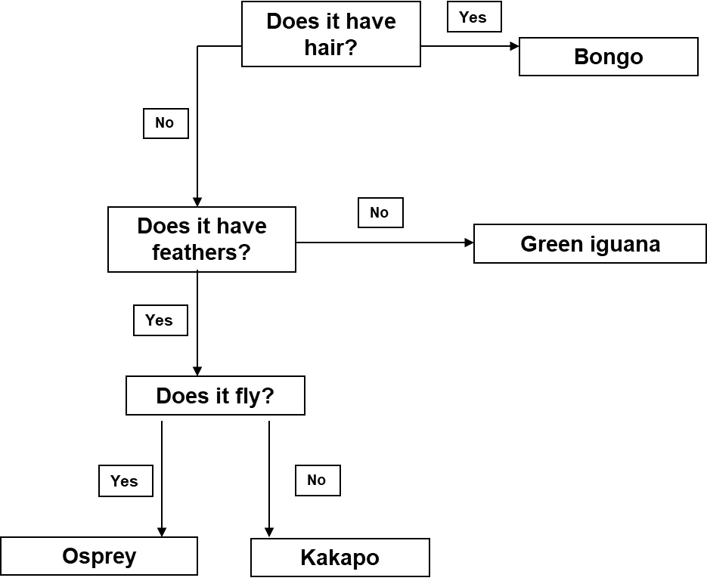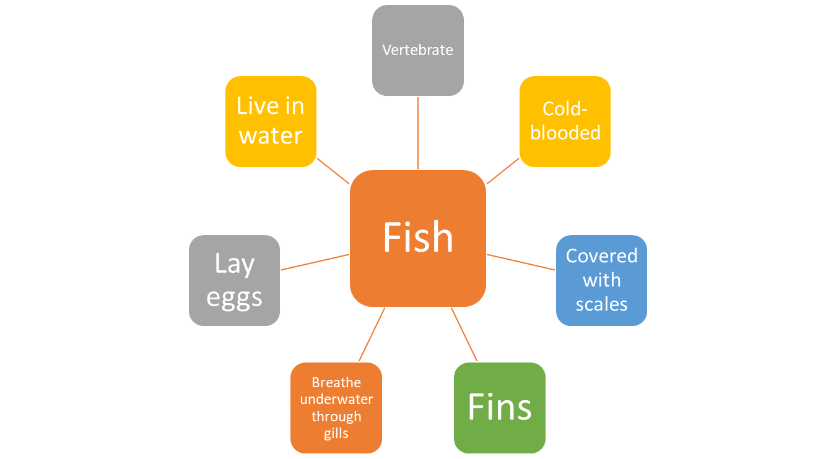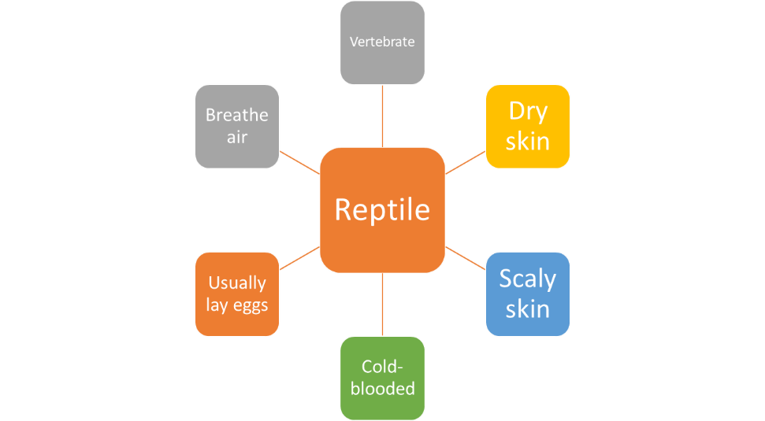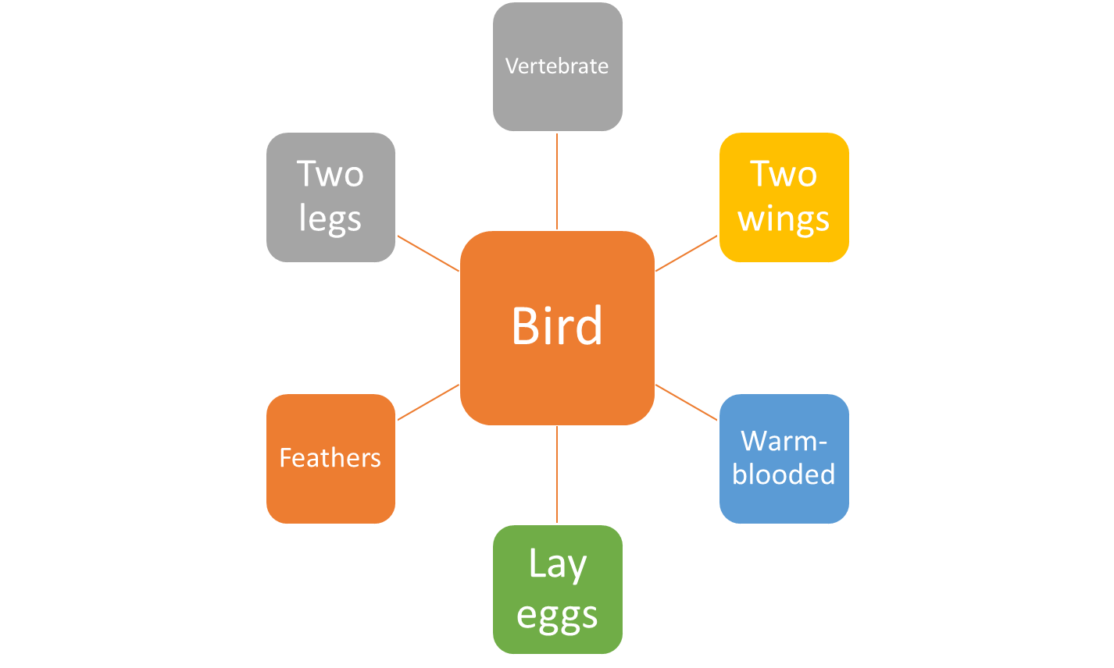

Always start with the first question.

The answer to each question should always be ‘yes’ or ‘no’.

Characteristics of vertebrate groups