
Knowledge Organiser – Animals including Humans (Science Year 5 and 6)
Key Vocabulary | Definition
Egg | An oval object laid by a female bird, reptile, fish or invertebrate that grows into a young offspring.
Live young | Are born to mammals.
Development | A new stage in a changing situation.
Adolescent | Developing from a child into an adult.
Puberty | When adolescents become able to reproduce.
Gestation | Process in which babies grow inside their mother's body before they are born.
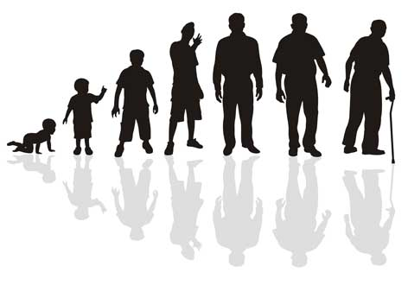
Baby
Toddler
Child
Adolescent
Adult
Old Age
Stages of the Human Life Cycle

Larger crystals that interlock.
Marble

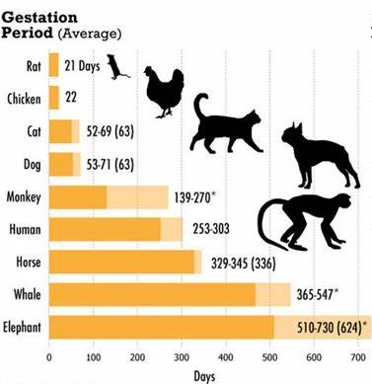
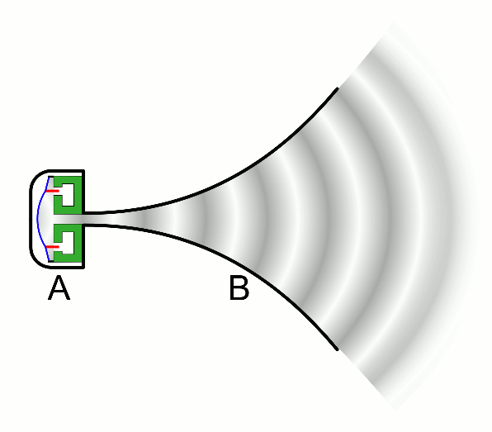
This continues in waves until the vibrations run out of energy. If the vibrations reach your ears, you will hear the sound.
- This is the period of time the fetus spends in the womb.
- The time starts from conception and ends at birth.
- For humans, the gestation period is around nine months.

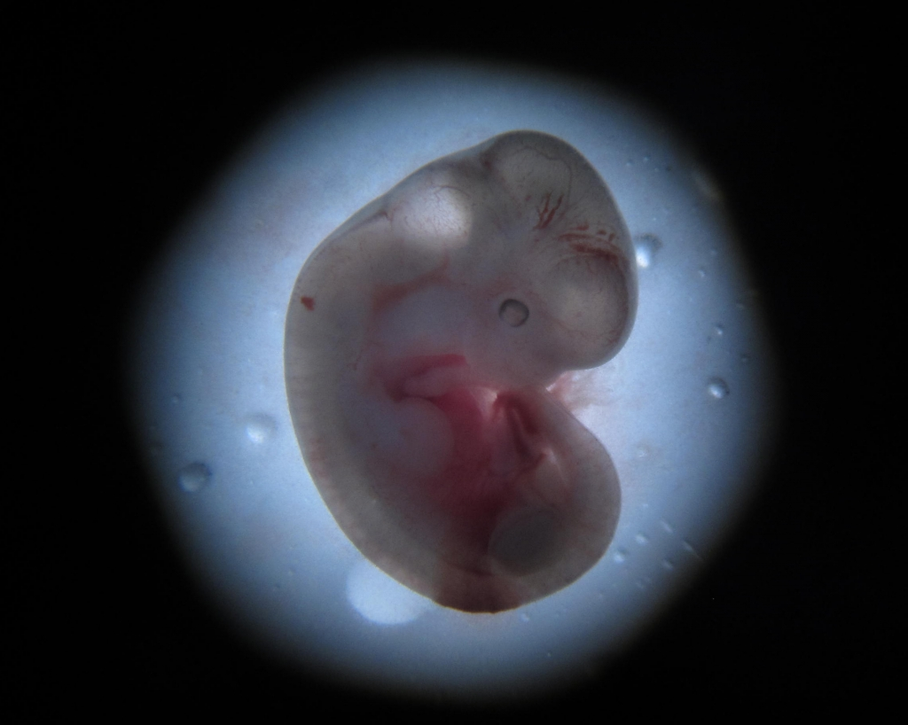
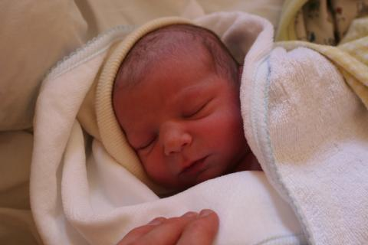

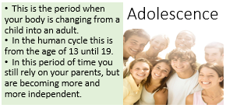
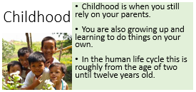
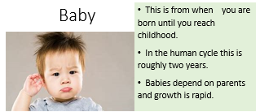

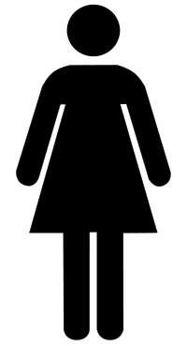
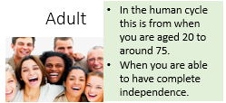
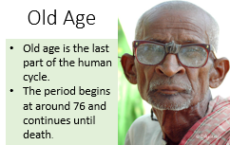
testicles mature and grow
hair on face grows
voice gets deeper
breasts start to grow
periods start
hips grow wider
pubic hair grows
body grows
Changes in Puberty

