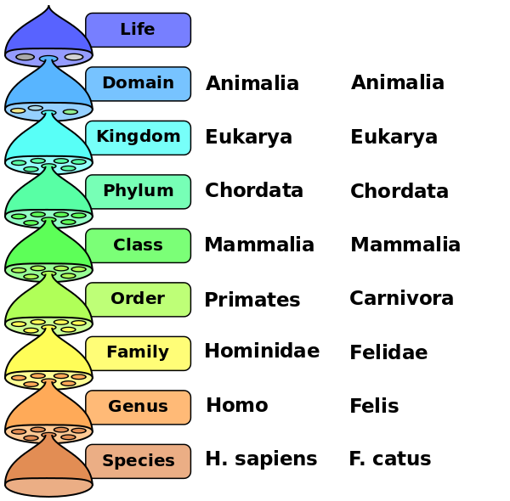** Knowledge Organiser – Living Things: Classification (Science Year 5 and 6)**

|  |  |
| --- | --- |
| **Key Vocabulary** | **Definition** |
| Organism | Individual living thing. |
| Micro-organism | An organism too small to be seen with the eye. |
| Fungus | Type of micro-organism. |
| Mushroom | Type of fungus. |
| Arachnid | Animal that has eight legs and a body formed in two parts. |
| Mollusc | Animal that has a soft body with no backbone and mainly covered by a shell. |
| Crustacean | Animal that has several pairs of legs and a body made up of sections covered in an exoskeleton. |

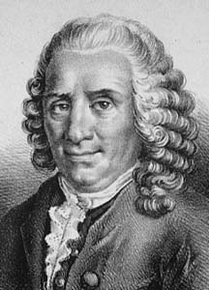

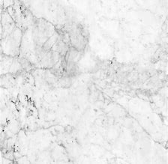

Larger crystals that interlock.

Marble

Carl Linnaeus developed a system of classifying animals and plants.

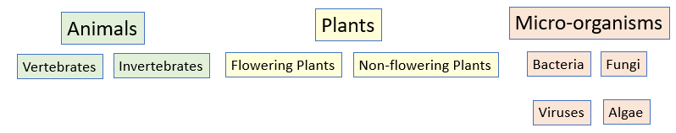

The similarities and differences that exist between living organisms allow us to put them into groups.

