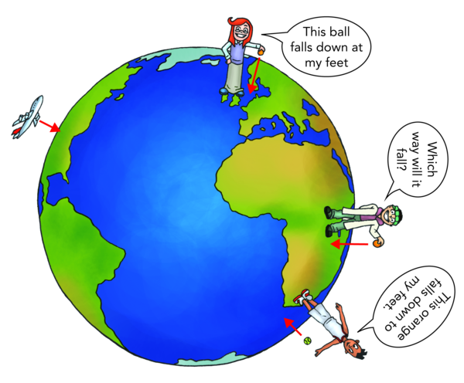** Knowledge Organiser – Forces (Science Year 5 and 6)**

The force of gravity causes objects to be pulled towards the (centre of the) Earth.

|  |  |
| --- | --- |
| **Key Vocabulary** | **Definition** |
| Gravity | Natural attraction between physical bodies. |
| Air resistance | Frictional force of air pushes against a moving object. |
| Water resistance | Frictional force of water pushes against a moving object. |
| Friction | Resistance to movement of one object moving against another. |
| Levers | Strong bars that are used to lift and move something heavy. |
| Pulley | Simple machine for moving heavy objects up or down, consisting of a small wheel over which a rope or chain is attached to the object. |
| Gears | Part of machines that meshes with another toothed part to make things move or to change speed or direction. |

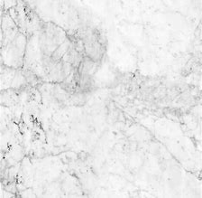

Larger crystals that interlock.

Marble

As the mass of the Earth is larger than the object, it falls towards it.

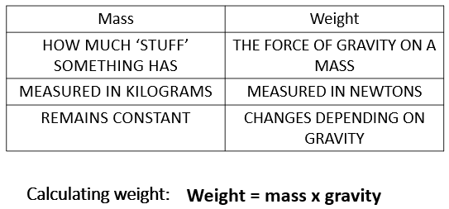

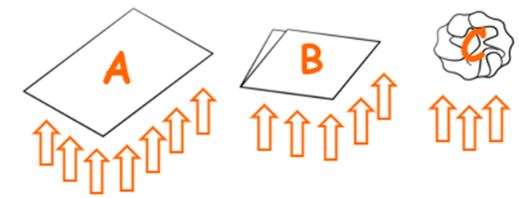

Friction between the object and air acts in the direction opposite to motion.

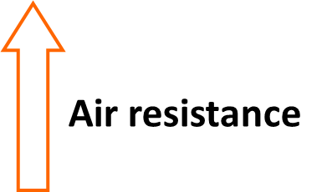

Air resistance is an upward force exerted on falling objects.

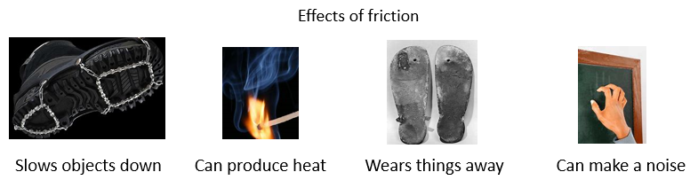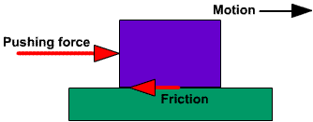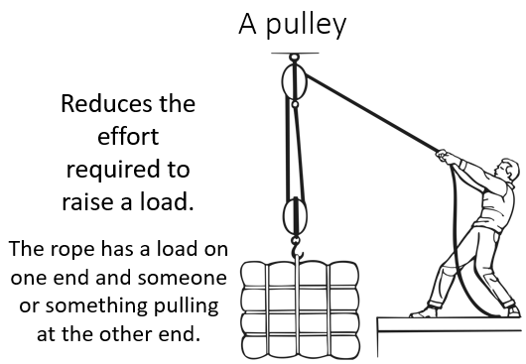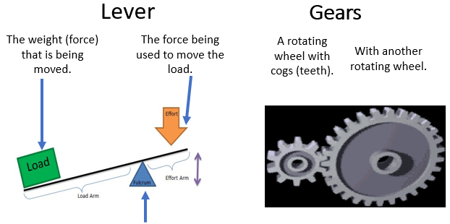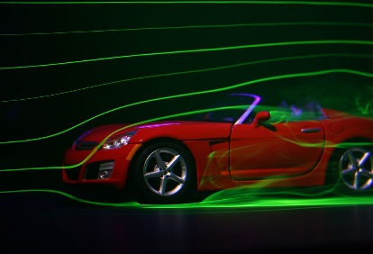

A simple machine (a mechanical device) is used to change:

• The size of a force.

• The direction of a force.

Friction is a force that reduces the speed of an object or may stop objects from moving.

Pulley

Reducing the air resistance will make it go faster.

Streamlined shapes cause less air resistance than others.