** Knowledge Organiser – Properties of Materials (Science Year 5 and 6)**

|  |  |
| --- | --- |
| **Key Vocabulary** | **Definition** |
| Electrical conductivity | Ability to conduct or transmit electricity. |
| Solubility | How well a substance dissolves. |
| Thermal conductivity | Ability to conduct or transmit heat. |
| Dissolve | To mix with a liquid and become part of the liquid. |
| Insoluble | Something that is not able to dissolve. |
| Filtering | Process to use when you can separate small objects. |
| Reversible change | Capable of being reversed. |

Examples of reversible changes that can change back to their original form.

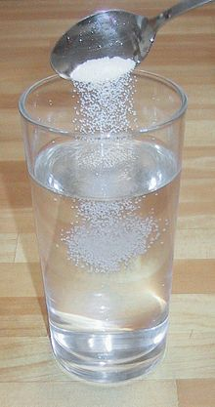

Larger crystals that interlock.

Marble

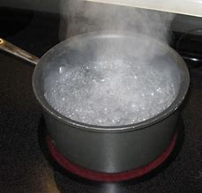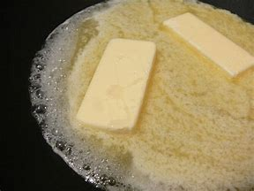

Melting butter

Boiling water

Ice cubes melting

Solution of sugar and water

When a solid (**solute**) dissolves in the liquid (**solvent**), a **solution** is formed.



[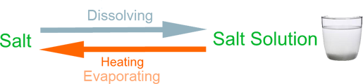](http://k8schoollessons.com/wp-content/uploads/2013/02/salt.png)



Most metals are good conductors of heat.

Some materials allow electric current to flow more freely than others e.g. metals. These materials are called electrical conductors.

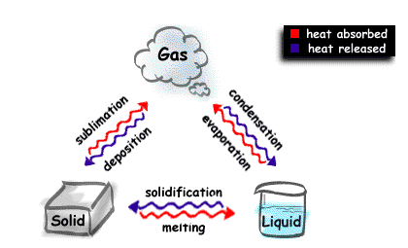

evaporating

sieving

filtering

Mixing materials together forms a mixture where two or more substances are physically combined. It can be separated by physical methods such as:

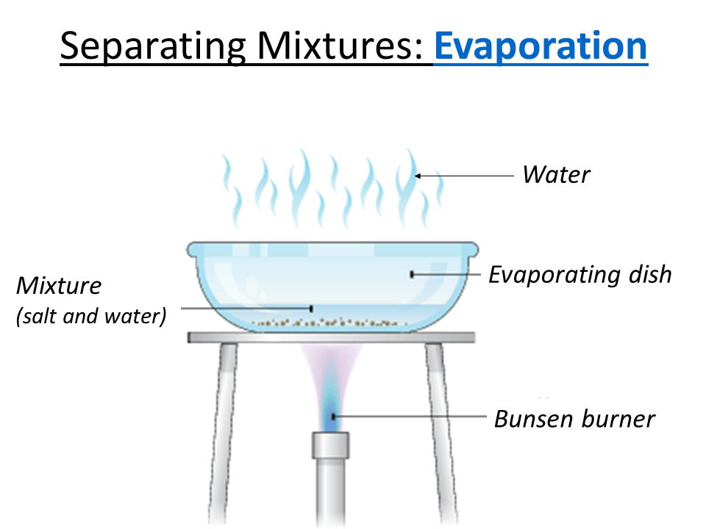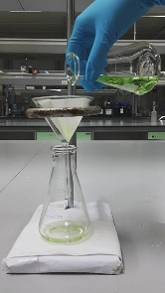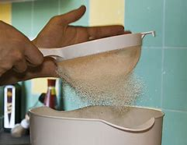

Examples of chemical changes are:

cooking and baking

Chemical changes produce new substances.

Evidence of a chemical reaction can be identified through:

Change of colour

Change of smell

Change of composition

The change cannot be reversed

State changes are reversible.

fermentation

rusting

burning

Separating soluble solids from liquids.

Separating different solids.

Separating insoluble solids from liquids.