
Knowledge Organiser – Space (Science Year 5 and 6)
All objects in the Solar System orbit the Sun in the same direction, in elliptical paths.
Key Vocabulary | Definition
Planet | Large celestial bodies.
Earth | Planet on which we live and the third in order from the Sun.
Sun | A star around which the Earth orbits.
Solar System | Collection of eight planets and their moons in orbit round the sun.
Moon | Earth’s natural satellite.
Celestial body | Object always present in the sky.
Orbit | Curved path of a celestial body.

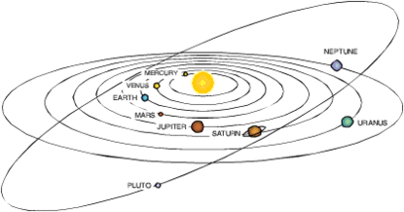

Larger crystals that interlock.
Marble

The Sun's massive amount of gravity, due to its huge mass, keeps the Solar System together.

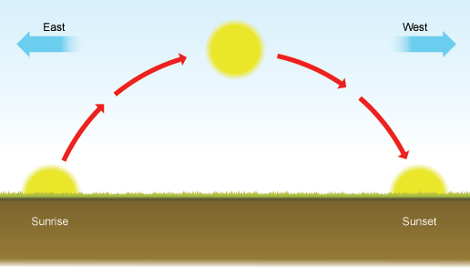
The Sun appears to move due to the Earth's rotation.
The Earth completes one full rotation every 24 hours.
A “year” is the period of time this planet takes to complete one orbit around the Sun.

Orbit = moves around
Rotate = spins around
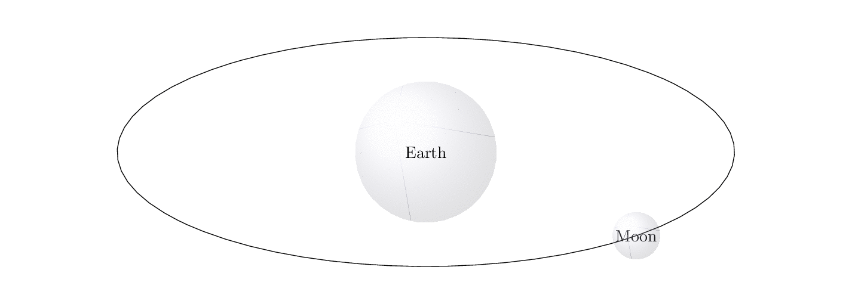
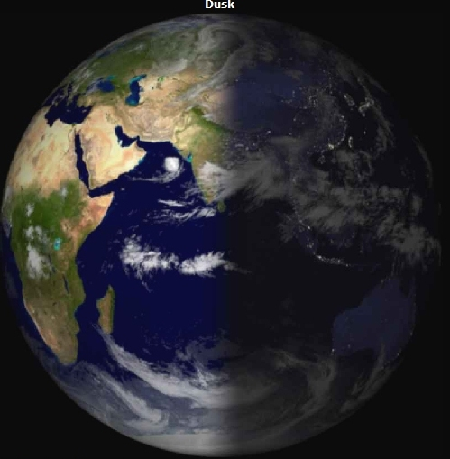
It takes the moon 28 days to orbit the Earth.
SUNLIGHT
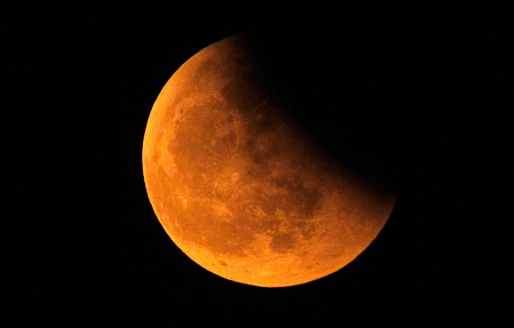
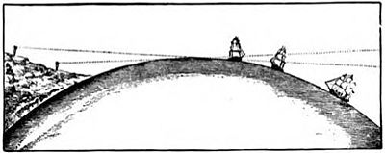
Ships disappearing over the horizon.
Shadow on the moon during an eclipse.

Evidence for the Earth being spherical:
When it is not facing the
Sun, it is night time.
When the place where you are on Earth is facing the sun, it is daytime.
Light
Dark

