
Year 5 Therapy Test 1

To support PLC statement
Y5 M4c. Can recognise mixed numbers and improper fractions

Commissioned by The PiXL Club Ltd.
June 2019

This resource is strictly for the use of member schools for as long as they remain members of The PiXL Club. It may not be copied, sold nor transferred to a third party or used by the school after membership ceases. Until such time it may be freely used within the member school.
All opinions and contributions are those of the authors. The contents of this resource are not connected with nor endorsed by any other company, organisation or institution.
PiXL Club Ltd endeavour to trace and contact copyright owners. If there are any inadvertent omissions or errors in the acknowledgements or usage, this is unintended and PiXL will remedy these on written notification.

© Copyright The PiXL Club Limited, 2019

Therapy Test 1

Y5 M4c. Can recognise mixed numbers and improper fractions

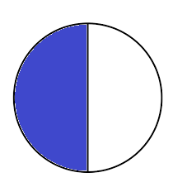
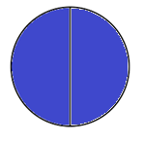
- Draw fraction circles for the following mixed numbers. The first has been done for you.
$$4\frac{1}{2}$$
$$3\frac{3}{4}$$

$$1\frac{2}{3}$$

- Draw fraction circles for the following improper fractions. The first has been done for you.
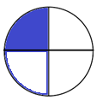

$$\frac{5}{4}$$
$$\frac{3}{2}$$
$$\frac{9}{4}$$
- Isabelle says the diagram shows $\frac{8}{4}$ . 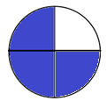
Do you agree? Explain your answer.
________________________________________________________
________________________________________________________

