
Year 5 Therapy Test 1

To support Priority Therapy M4m

Commissioned by The PiXL Club Ltd.
August 2018

This resource is strictly for the use of member schools for as long as they remain members of The PiXL Club. It may not be copied, sold nor transferred to a third party or used by the school after membership ceases. Until such time it may be freely used within the member school.
All opinions and contributions are those of the authors. The contents of this resource are not connected with nor endorsed by any other company, organisation or institution.
PiXL Club Ltd endeavour to trace and contact copyright owners. If there are any inadvertent omissions or errors in the acknowledgements or usage, this is unintended and PiXL will remedy these on written notification.

© Copyright The PiXL Club Limited, 2018

Therapy Test 1 M4m
(to accompany the Year 5 Priority Therapy)

M4m. Can recognise the % symbol and understand that it relates to the number of parts per hundred.

- Shade in the given percentage of each grid.

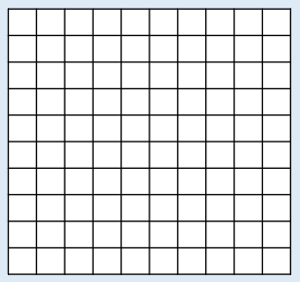
75% 67% 42%

- Convert the following percentages into a fraction
- 78%
- 34%
- 25%

- Write down what percentage is required to make a whole
- 56% + ______% = one whole
- 24% + ______% = one whole
- 99% + ______% = one whole

- I tossed a coin 10 times. 70% of the tosses landed on heads. What percentage of the tosses did it land on tails?

