
Year 5 Therapy Test 1

To support M5f – Can estimate volume

Commissioned by The PiXL Club Ltd.
November 2019

This resource is strictly for the use of member schools for as long as they remain members of The PiXL Club. It may not be copied, sold nor transferred to a third party or used by the school after membership ceases. Until such time it may be freely used within the member school.
All opinions and contributions are those of the authors. The contents of this resource are not connected with nor endorsed by any other company, organisation or institution.
PiXL Club Ltd endeavour to trace and contact copyright owners. If there are any inadvertent omissions or errors in the acknowledgements or usage, this is unintended and PiXL will remedy these on written notification.

© Copyright The PiXL Club Limited, 2019

Therapy Test 1

Y5 M5f. Can estimate volume

- PRACTICAL TASK: Use resources to create a cuboid with a volume of 20m³.

- What is the estimated volume of this cube? Give your answer in cm³.
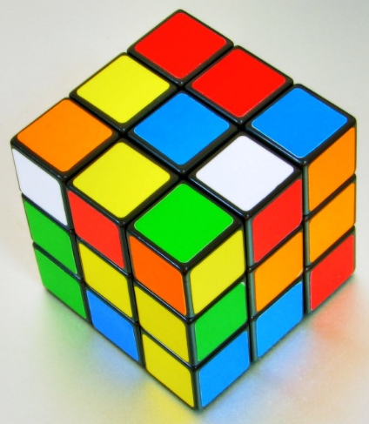
Answer:

- Label the following cuboid with the dimensions needed to work out the volume. Explain your reasoning.

________________________________________________________________
________________________________________________________________

________________________________________________________________

