
Year 5 Therapy Test 1

To support M5g – Can estimate capacity

Commissioned by The PiXL Club Ltd.
November 2019

This resource is strictly for the use of member schools for as long as they remain members of The PiXL Club. It may not be copied, sold nor transferred to a third party or used by the school after membership ceases. Until such time it may be freely used within the member school.
All opinions and contributions are those of the authors. The contents of this resource are not connected with nor endorsed by any other company, organisation or institution.
PiXL Club Ltd endeavour to trace and contact copyright owners. If there are any inadvertent omissions or errors in the acknowledgements or usage, this is unintended and PiXL will remedy these on written notification.

© Copyright The PiXL Club Limited, 2019

Therapy Test 1

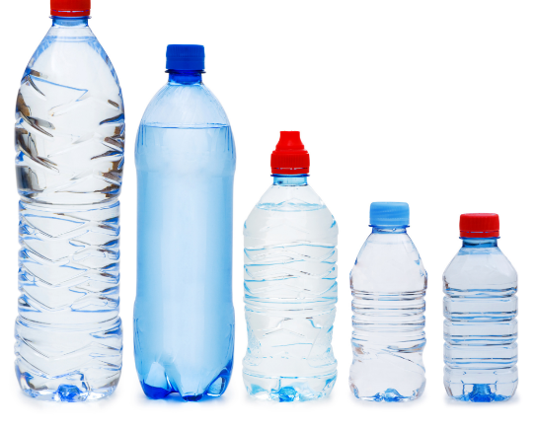
Y5 M5g. Can estimate capacity

- When full, this bottle holds 800ml of liquid. Estimate the amount of liquid shown by the marked line.

Answer:

- The largest container holds 500ml of water. Estimate the total capacity of all 5 bottles. Explain your reasoning.

________________________________________________________________
________________________________________________________________

________________________________________________________________

- PRACTICAL ACTIVITY: Select 4 different containers with liquid in them. Estimate their capacity and put them into ascending order. Then measure the actual capacity of each container and see how close the measurement is to your estimations.

